User Guide

for

ORN Segment with Address

LIO Data Class

Provincial Mapping Unit

Mapping and Information Resources Branch

Corporate Management and Information Division

Ministry of Natural Resources and Forestry

2019-03-22

Disclaimer

This technical documentation has been prepared by Her Majesty the Queen in right of Ontario as represented by the Ministry of Natural Resources and Forestry (the “Ministry”). No warranties or representations, express or implied, statutory or otherwise shall apply or are being made by the Ministry with respect to the documentation, its accuracy or its completeness. In no event will the Ministry be liable or responsible for any lost profits, loss of revenue or earnings, claims by third parties or for any economic, indirect, special, incidental, consequential or exemplary damage resulting from any errors, inaccuracies or omissions in this documentation; and in no event will the Ministry’s liability for any such errors, inaccuracies or omissions on any particular claim, proceeding or action, exceed the actual consideration paid by the claimant involved to the Ministry for the materials to which this instructional documentation relates. Save and except for the liability expressly provided for above, the Ministry shall have no obligation, duty or liability whatsoever in contract, tort or otherwise, including any liability or negligence. The limitations, exclusions and disclaimers expressed above shall apply irrespective of the nature of any cause of action, demand or action, including but not limited to breach of contract, negligence, strict liability, tort or any other legal theory, and shall survive any fundamental breach or breaches.

Cette publication spécialisée n’est disponible qu’en anglais.

Additional Information

This document does not comply with all the applicable guidelines for accessible digital documents. For an alternative format please email Land Information Ontario at [lio@ontario.ca](mailto:lio@ontario.ca).

For more information about this document, please contact Land Information Ontario at [lio@ontario.ca](mailto:lio@ontario.ca).

Executive Summary

Key Words

Ontario Road Network, ORN

Abstract

This user guide details the specifications for the ORN Segment with Address (ORNSEGAD) Land Information Ontario (LIO) Data Class. With a positional accuracy of 10 metres or better the ORN is the authoritative source of roads data for Ontario. ORNSEGAD is derived from the ORN Road Net Element (ORNELEM) data class and is suitable for creating products and services including mapping, analysis and geocoding applications.

The ORN is a Government of Ontario Information Technology Standard (GO-ITS 29). Refer to Links to Additional Information for more information.

Table of Contents

Disclaimer 2

Additional Information 2

Executive Summary 3

Key Words 3

Abstract 3

Table of Contents 4

List of Figures 6

List of Tables 7

List of Acronyms 8

1. Introduction 9

2. Objectives 9

3. Data Class: ORN Segment with Address (ORNSEGAD) 9

4. Model Diagram: ORN Segment with Address (ORNSEGAD) 10

5. Data Description 12

ORN_SEGMENT_WITH_ADDRESS_FT 12

6. Best Practices and Product Limitations 16

ORN Segment with Address (ORNSEGAD) contains fewer attributes than ORN Road Net Element (ORNELEM) 16

7. Links to Additional Information 17

APPENDIX A: LIO Lookup Tables and Values 18

ORN_DIR_OF_TRAFFIC_FLOW_LIST 18

ORN_HOUSE_NUM_STRUCTURE_LIST 18

ORN_ROAD_CLASS_LIST 20

ORN_ROAD_ELEMENT_TYPE_LIST 21

ORN_SHIELD_TYPE_LIST 22

ORN_STANDARD_MUNICIPALITY_LIST 23

ORN_STREET_DIRECTION_LIST 39

ORN_STREET_TYPE_LIST 40

APPENDIX B: Table Key Dependency and Relationship Index 47

Main Business Area Tables 49

Lookup Table Indexes 49

APPENDIX C: Frequently Asked Questions 52

What is the difference between ORN Road Net Element (ORNELEM) and ORN Segment with Address (ORNSEGAD)? 52

What is a Linear Reference System (LRS)? 53

Where are the attribute tables for the ORN_ROAD_NET_ELEMENT data class? 53

Why can’t I see ORN attributes like Speed Limit or Road Class in ArcMap? 55

How do I display ORN Route Events in ArcMap? 55

How do I display the ORN_JUNCTION table in ArcMap? 57

How do I join ORN tables or event layers? 58

How do I access ORN attributes for analysis? 59

Where do I find 911 addresses? 59

What is the difference between 911 and civic addresses? 59

What is the difference between shield type and road class? 59

What is the difference between the Jurisdiction, Agency Name, and Road Net Element Source tables? 60

What projection is used to calculate LENGTH in ORN? 60

I found a road with an offensive or rescinded name in the ORN. Are you able to rename the road or remove the name? 60

I still need help! 61

APPENDIX D: Creating a Network with ORN Segment with Address (ORNSEGAD) 62

1. Introduction 62

2. Creating the Network 62

2.1. Steps for Preparing the ORNSEGAD 62

2.2. Steps to Create the Network Dataset 64

2.3. Steps to Define the Network Attributes 68

2.4. Steps to Establish Driving Directions 79

2.5. Steps to Finish Building the Network Dataset 82

List of Figures

Figure 1: Primary Key example 47

Figure 2: Foreign Key example 47

Figure 3: Alternate Key example 47

Figure 4: Example of an Identifying Relationship 48

Figure 5: Example of a Non-identifying Relationship 48

Figure 6: Model Diagram Relationship Symbology Table 48

Figure 7: Attribute tables included through LIO Metadata Management Tool 54

Figure 8: Check 'Include Related Tables' when ordering LIO data 54

Figure 9: ArcMap's Display Route Events 56

Figure 10: ArcMap's Display XY Data 57

Figure 11: ArcMap's Join Data 58

Figure 12 – Add a new field for speed values 63

Figure 13 – Select features by road class 64

Figure 14 – Calculate the desired speed 64

Figure 15 – Enable the “Network Analyst” extension 65

Figure 16 – Create a new network dataset 66

Figure 17 – Enter a name for the new network dataset. 66

Figure 18 – Select the “Yes” radio button to model turns in the network. 67

Figure 19 – Accept the default connectivity settings 67

Figure 20 – Do not select an elevation model for the network. 68

Figure 21 – Add the network attributes 69

Figure 22 – Select the OneWay attribute 70

Figure 23 – Set OneWay evaluators 71

Figure 24 – Calculate the OneWay expression value 72

Figure 25 – Select the Rd_Class attribute 73

Figure 26 – Set the Rd_Class evaluators 74

Figure 27 – Calculate the road class value 75

Figure 28 – Select the speed attribute 76

Figure 29 – Set the speed evaluators 77

Figure 30 – Select the time attribute 77

Figure 31 – Set the time evaluators 78

Figure 32 – Calculate the time evaluators 78

Figure 33 – The travel mode window 79

Figure 34 – The driving directions window 80

Figure 35 – Set the network direction properties 81

Figure 36 – Set the shield values 82

Figure 37 – The network dataset summary 83

Figure 38 – Build the network dataset 83

Figure 39 –The network dataset 84

Figure 40 – The Network Analyst tools. 84

List of Tables

Table 1 – Possible speed limits for ORN road classes 62

Table 2 – Add these attributes to the Network Dataset 68

Table 3 – Possible values in the “DIRECTION” field 69

Table 4 – Expressions for enforcing traffic flow directions 71

Table 5 – Network direction field values 81

List of Acronyms

CPC: Canada Post Corporation

GO-ITS: Government of Ontario Information Technology Standard

LIO: Land Information Ontario

LUT: Lookup Table

MMAH: Ontario Ministry of Municipal Affairs and Housing

MNRF: Ontario Ministry of Natural Resources and Forestry

MTO: Ontario Ministry of Transportation

NRN: National Road Network

OGF: Ontario Geospatial Feature

ORN: Ontario Road Network

WMS: Web Map Service

1. Introduction

The Ontario Road Network (ORN) is a province-wide geographic database of over 275,000 kilometres of municipal roads, provincial highways and resource and recreational roads. With a positional accuracy of 10 metres or better the ORN is the authoritative source of roads data for Ontario.

The ORN is a national, provincial and municipal initiative that supports the creation, maintenance and sharing of a standard road database. Land Information Ontario (LIO) maintains the ORN using data from the road authorities with legislative responsibility: Ontario Municipalities, Ontario Ministry of Transportation (MTO) and Ontario Ministry of Natural Resources and Forestry (MNRF). Roads data and information is collected, standardized and integrated into a seamless road mapping product.

Users can access current ORN data through a Web Map Service (WMS) or an open data license to create products and services including mapping, analysis and geocoding applications. Up-to-date data is available at no cost to public and private organizations, saving time, resources and money.

For more information on the ORN contact [lio@ontario.ca](mailto:lio@ontario.ca).

2. Objectives

This guide is intended for users with a general interest in the ORN Segment with Address LIO Data Class. The remainder of this document describes the extent and context of the information collected for the data class.

3. Data Class: ORN Segment with Address (ORNSEGAD)

ORNSEGAD is derived from the ORN Road Net Element (ORNELEM) data class and combines three types of geometry from ORNELEM: road elements, ferry connections, and virtual roads. Address ranges span intersection to intersection or may be interpolated across intersections.

ORNSEGAD contains five attributes: Street Name, Address Information, Route Identification, Road Classification, and Direction of Traffic Flow. For additional road attribution, see ORN Road Net Element (ORNELEM).

For more detailed information refer to the ORNSEGAD data model diagram and Appendix B: Table Key Dependency and Relationship Index.

4. Model Diagram: ORN Segment with Address (ORNSEGAD)

Physical Model Diagram for: ORN Segment with Address (ORNSEGAD)

Model Effective Date: 2012-JUN-14

**Note**: Where applicable to this model:

* Tables with a “_LIST” extension (shaded yellow) = Lookup Table (LUT)

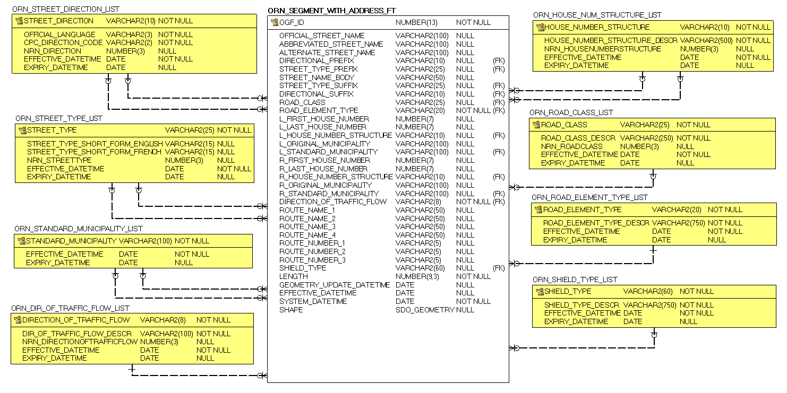

5. Data Description

The main business area table(s) for this model can be found below. Associated lookup tables will be listed in Appendix A of this document and are hyperlinked where referenced in this section.

ORN_SEGMENT_WITH_ADDRESS_FT

A road segment that represents a centreline network representing roads and their associated addresses.

| Column Name | Column Type | Mandatory | Short Name | Description |
| --- | --- | --- | --- | --- |
| OGF_ID | NUMBER(13) | Yes | OGF_ID | Ontario Geospatial Feature Identifier: A unique numeric provincial identifier assigned to each object. |
| OFFICIAL_STREET_NAME | VARCHAR2(100) | No | FULL_NAME | Street name composed of individual street name components where present, including directional prefix, street type prefix, street name body, street type suffix and directional suffix. |
| ABBREVIATED_STREET_NAME | VARCHAR2(100) | No | ABBR_NAME | Abbreviated street name is composed of the individual street name components, where present, including directional prefix, street type prefix, street name body, street type suffix and directional suffix. Street name components are abbreviated with the exception of street name body. |
| ALTERNATE_STREET_NAME | VARCHAR2(100) | No | ALT_NAME | Alternate name attached to a road segment not associated to an established route. |
| DIRECTIONAL_PREFIX | VARCHAR2(10) | No | DIR_PREFIX | A geographic direction preceding either the street type prefix or the street name body.  Permissible Values: (See ORN_STREET_DIRECTION_LIST lookup table in appendix) |
| STREET_TYPE_PREFIX | VARCHAR2(25) | No | ST_TYPE_P | A street type preceding the street name body.  Permissible Values: (See ORN_STREET_TYPE_LIST lookup table in appendix) |
| STREET_NAME_BODY | VARCHAR2(50) | Yes | NAME_BODY | The identifying named component of a street name. Street segment must have a street name body and can never be abbreviated. |
| STREET_TYPE_SUFFIX | VARCHAR2(25) | No | ST_TYPE_S | A street type following the street name body.  Permissible Values: (See ORN_STREET_TYPE_LIST lookup table in appendix) |
| DIRECTIONAL_SUFFIX | VARCHAR2(10) | No | DIR_SUFFIX | A geographic direction following either the street name body or the street type suffix.  Permissible Values: (See ORN_STREET_DIRECTION_LIST lookup table in appendix) |
| ROAD_CLASS | VARCHAR2(25) | No | ROAD_CLASS | The functional classification of the road segment.  Permissible Values: (see ORN_ROAD_CLASS_LIST lookup table in appendix) |
| ROAD_ELEMENT_TYPE | VARCHAR2(20) | Yes | ELEM_TYPE | An attribute describing the type of road segment. Valid values:  Permissible Values: (See ORN_ROAD_ELEMENT_TYPE_LIST lookup table in appendix) |
| L_FIRST_HOUSE_NUMBER | NUMBER(7,0) | No | L_FIRST | The first house number of the address range on the left side of a road segment. |
| L_LAST_HOUSE_NUMBER | NUMBER(7,0) | No | L_LAST | The last house number of the address range on the left side of a road segment. |
| L_HOUSE_NUMBER_STRUCTURE | VARCHAR2(10) | No | L_STRUCT | The type of addressing method applied to the left side of a road segment.  Permissible Values: (See ORN_HOUSE_NUM_STRUCTURE_LIST lookup table in appendix) |
| L_ORIGINAL_MUNICIPALITY | VARCHAR2(100) | No | L_ORIG_MUN | The municipality name applied to the left side of a road segment as provided. |
| L_STANDARD_MUNICIPALITY | VARCHAR2(100) | No | L_STD_MUN | The standardized municipality applied to the left side of the road segment as provided by the Ministry of Municipal Affairs and Housing (MMAH) and Indian Reserves.  Permissible Values: (See ORN_STANDARD_MUNICIPALITY_LIST lookup table in appendix) |
| R_FIRST_HOUSE_NUMBER | NUMBER(7,0) | No | R_FIRST | The first house number of the address range on the right side of a road segment. |
| R_LAST_HOUSE_NUMBER | NUMBER(7,0) | No | R_LAST | The last house number of the address range. |
| R_HOUSE_NUMBER_STRUCTURE | VARCHAR2(10) | No | R_STRUCT | The type of addressing method applied to the right side of a road segment.  Permissible Values: (See ORN_HOUSE_NUM_STRUCTURE_LIST lookup table in appendix) |
| R_ORIGINAL_MUNICIPALITY | VARCHAR2(100) | No | R_ORIG_MUN | The municipality name applied to the right side of a road segment as provided. |
| R_STANDARD_MUNICIPALITY | VARCHAR2(100) | No | R_STD_MUN | The standardized municipality applied to the right side of the road segment as provided by the Ministry of Municipal Affairs and Housing (MMAH) and Indian Reserves.  Permissible Values: (See ORN_STANDARD_MUNICIPALITY_LIST lookup table in appendix) |
| DIRECTION_OF_TRAFFIC_FLOW | VARCHAR2(8) | Yes | DIRECTION | The direction of traffic flow applied to the road segment.  Permissible Values: (See ORN_DIR_OF_TRAFFIC_FLOW_LIST lookup table in appendix) |
| ROUTE_NAME_1 | VARCHAR2(50) | No | RTE_NAME_1 | The name of an established route. |
| ROUTE_NAME_2 | VARCHAR2(50) | No | RTE_NAME_2 | The name of an established route. |
| ROUTE_NAME_3 | VARCHAR2(50) | No | RTE_NAME_3 | The name of an established route. |
| ROUTE_NAME_4 | VARCHAR2(50) | No | RTE_NAME_4 | The name of an established route. |
| ROUTE_NUMBER_1 | VARCHAR2(5) | No | RTE_NUM_1 | The route number represented by a numeric and/or an alphanumeric character associated with a provincial highway, secondary highway, county road or regional road. |
| ROUTE_NUMBER_2 | VARCHAR2(5) | No | RTE_NUM_2 | The route number represented by a numeric and/or an alphanumeric character associated with a provincial highway, secondary highway, county road or regional road. |
| ROUTE_NUMBER_3 | VARCHAR2(5) | No | RTE_NUM_3 | The route number represented by a numeric and/or an alphanumeric character associated with a provincial highway, secondary highway, county road or regional road. |
| SHIELD_TYPE | VARCHAR2(60) | No | SHIELD_T | The shield type classified by a route and used for cartographic purposes.  Permissible Values: (See ORN_SHIELD_TYPE_LIST lookup table in appendix) |
| LENGTH | NUMBER(9,3) | Yes | LENGTH | The length of the segment in metres. |
| GEOMETRY_UPDATE_DATETIME | DATE | No | GEO_UPD_DT | Date/time the geometry was created or last modified in the source database. |
| EFFECTIVE_DATETIME | DATE | Yes | EFF_DATE | Date/time the record was created or last modified in the source database. |
| SHAPE | SDO_GEOMETRY | No | SHAPE | Geometry attribute. |

6. Best Practices and Product Limitations

ORN Segment with Address (ORNSEGAD) contains fewer attributes than ORN Road Net Element (ORNELEM)

ORNSEGAD is a segmented data class derived from ORNELEM and includes fewer attributes. This may create issues when using ORNSEGAD for network analysis or routing purposes. For example, speed limits and blocked passages are not included in ORNSEGAD. If these attributes are required, one could derive them from the ORNELEM data class or create their own as in Appendix D.

7. Links to Additional Information

* Official LIO Metadata Record for [ORN Segment with Address](https://www.javacoeapp.lrc.gov.on.ca/geonetwork/srv/en/main.home?uuid=c7c7202d-942d-47dc-bb15-259eb71f2551) (https://www.javacoeapp.lrc.gov.on.ca/geonetwork/srv/en/main.home?uuid=c7c7202d-942d-47dc-bb15-259eb71f2551)
* [Land Information Ontario (LIO)](https://www.ontario.ca/environment-and-energy/land-information-ontario) (https://www.ontario.ca/environment-and-energy/land-information-ontario)
* Canadian Federal Government’s GeoGratis: [National Road Network](http://geogratis.gc.ca/api/en/nrcan-rncan/ess-sst/c0d1f299-179c-47b2-bcd8-da1ba68a8032.html) (http://geogratis.gc.ca/api/en/nrcan-rncan/ess-sst/c0d1f299-179c-47b2-bcd8-da1ba68a8032.html)
* GO-ITS 29: [Ontario Road Network](https://www.ontario.ca/government/go-its-29-ontario-road-network) (https://www.ontario.ca/government/go-its-29-ontario-road-network)

APPENDIX A: LIO Lookup Tables and Values

ORN_DIR_OF_TRAFFIC_FLOW_LIST

List of valid direction of traffic flows.

| Column Name | Column Type | Mandatory | Short Name | Description |
| --- | --- | --- | --- | --- |
| DIRECTION_OF_  TRAFFIC_FLOW | VARCHAR2(8) | Yes | DIRECTION_ | The direction(s) of vehicular or motor traffic flow. All road elements must have a direction of traffic flow assigned. |
| DIR_OF_TRAFFIC_  FLOW_DESCR | VARCHAR2(100) | Yes | DESCR | A description of the direction of traffic flow. |
| NRN_DIRECTIONOF  TRAFFICFLOW | NUMBER(3,0) | No | NRN_CODE | Direction of traffic flow assigned to support the National Road Network (NRN). |
| EFFECTIVE_  DATETIME | DATE | Yes | EFF_DATE | Date/time the record was created or last modified in the source database. |
| EXPIRY_DATETIME | DATE | No | EXP_DATE | Date/time that the record was expired from use. |

**ORN_DIR_OF_TRAFFIC_FLOW_LIST Permissible Values**

| DIRECTION OF TRAFFIC FLOW | DIR OF TRAFFIC FLOW DESCR | NRN DIRECTIONOF  TRAFFICFLOW | EXPIRY  DATETIME |
| --- | --- | --- | --- |
| Both | Traffic is allowed in both directions. | 1 | Not applicable |
| Negative | Traffic is opposite to the direction of the geometry. | 3 | Not applicable |
| Positive | Traffic is in the same direction as the geometry. | 2 | Not applicable |

ORN_HOUSE_NUM_STRUCTURE_LIST

List of valid house number structures.

| Column Name | Column Type | Mandatory | Short Name | Description |
| --- | --- | --- | --- | --- |
| HOUSE_NUMBER_  STRUCTURE | VARCHAR2(10) | Yes | NUM_STRUCT | The type of house or property numbering system that is applied to the address range. |
| HOUSE_NUMBER_  STRUCTURE_DESCR | VARCHAR2(500) | Yes | NUM_STR_D | A description of the house number structure. |
| NRN_HOUSENUMBER  STRUCTURE | NUMBER(3,0) | No | NRN_CODE | House number structure assigned to support the National Road Network (NRN). |
| EFFECTIVE_  DATETIME | DATE | Yes | EFF_DATE | Date/time the record was created or last modified in the source database. |
| EXPIRY_DATETIME | DATE | No | EXP_DATE | Date/time that the record was expired from use. |

**ORN_HOUSE_NUM_STRUCTURE_LIST Permissible Values**

| HOUSE NUMBER STRUCTURE | HOUSE NUMBER STRUCTURE DESCR | NRN HOUSE NUMBER STRUCTURE | EXPIRY  DATETIME |
| --- | --- | --- | --- |
| Even | The house numbers appear as even numbers in a sequential sorted order (ascending or descending) when moving from one end of an address information event to the other. Numeric completeness of the series is not a requirement. | 1 | Not applicable |
| Irregular | The house numbers do not occur in any sorted order. | 4 | Not applicable |
| Mixed | The house numbers are odd and even on the same side of an address information event in sequential order (asc or desc) when moving from one end of the address information event to the other. Numeric completeness of the series is not a requirement. | 3 | Not applicable |
| None | No house numbers at all. There are no houses (or addressed dwellings) along a particular side of an address information event. | 0 | Not applicable |
| Odd | The house numbers appear as odd numbers in a sequential sorted order (ascending or descending) when moving from one end of the address information event to the other. Numeric completeness of the series is not a requirement. | 2 | Not applicable |

ORN_ROAD_CLASS_LIST

List of valid road classes.

| Column Name | Column Type | Mandatory | Short Name | Description |
| --- | --- | --- | --- | --- |
| ROAD_CLASS | VARCHAR2(25) | Yes | ROAD_CLASS | The classification of a road. |
| ROAD_CLASS_  DESCR | VARCHAR2(250) | Yes | ROAD_CLASS | A description of the road class. |
| NRN_ROADCLASS | NUMBER(3,0) | No | NRN_CODE | Road class assigned to support the National Road Network (NRN). |
| EFFECTIVE_  DATETIME | DATE | Yes | EFF_DATE | Date/time the record was created or last modified in the source database. |
| EXPIRY_DATETIME | DATE | No | EXP_DATE | Date/time that the record was expired from use. |

**ORN_ROAD_CLASS_LIST Permissible Values**

| ROAD CLASS | ROAD CLASS DESCR | NRN ROAD  CLASS | EXPIRY  DATETIME |
| --- | --- | --- | --- |
| Alleyway / Laneway | A low speed thoroughfare dedicated to provide access to the rear of properties. | 8 | Not applicable |
| Arterial | A major thoroughfare with medium to large traffic capacity | 3 | Not applicable |
| Collector | A minor thoroughfare mainly used to access properties and to feed traffic with right of way. | 4 | Not applicable |
| Expressway / Highway | A high-speed thoroughfare with a combination of controlled access and intersections at grade level. | 2 | Not applicable |
| Freeway | An unimpeded, high speed controlled access thoroughfare for through traffic with typically no at grade intersections, usually with no property access or direct access and which is accessed by a ramp. Pedestrians prohibited. | 1 | Not applicable |
| Local / Strata | A low speed thoroughfare dedicated to provide access to properties with potential public restriction, trailer parks, First Nations, strata or private estates. | 6 | Not applicable |
| Local / Street | A low speed thoroughfare dedicated to provide full access to the front of properties. | 5 | Not applicable |
| Local / Unknown | A low speed thoroughfare dedicated to provide access to the front of properties but for which the access regulations are unknown. | 7 | Not applicable |
| Ramp | A system of interconnecting roadways providing for the controlled movement between two or more roadways. | 9 | Not applicable |
| Rapid Transit | A thoroughfare restricted 24 hours a day, for the sole use of public transportation buses. | 11 | Not applicable |
| Resource / Recreation | A narrow passage which has as a primary function access for resources extraction and also may have a role in providing an access for the public to back country. | 10 | Not applicable |
| Service | A stretch of road permitting vehicles to come to a stop along a Freeway or Highway. These include weigh scales, emergency lanes, lookouts and rest areas. | 12 | Not applicable |
| Winter | A road that is only useable during the winter months when conditions allow for passage over lakes, rivers and wetlands. | 13 | Not applicable |

ORN_ROAD_ELEMENT_TYPE_LIST

List of valid road element types.

| Column Name | Column Type | Mandatory | Short Name | Description |
| --- | --- | --- | --- | --- |
| ROAD_ELEMENT_  TYPE | VARCHAR2(20) | Yes | ELEM_TYPE | An attribute describing the type of road net element. |
| ROAD_ELEMENT_  TYPE_DESCR | VARCHAR2(750) | Yes | ELEM_TYP_D | A description of the road element type. |
| EFFECTIVE_  DATETIME | DATE | Yes | EFF_DATE | Date/time the record was created or last modified in the source database. |
| EXPIRY_DATETIME | DATE | No | EXP_DATE | Date/time that the record was expired from use. |

**ORN_ROAD_ELEMENT_TYPE_LIST Permissible Values**

| ROAD ELEMENT TYPE | ROAD ELEMENT TYPE DESCR | EXPIRY DATETIME |
| --- | --- | --- |
| FERRY CONNECTION | The approximate route a ferry travels to transport vehicles across water and is linked to a road element by a junction. | Not applicable |
| ROAD ELEMENT | The basic centreline road feature spanning from intersection to intersection, or intersection to end where there is no subsequent intersection with another road. | Not applicable |
| VIRTUAL ROAD | A linear feature that is used as an address anchor for Bell 911 address information that is collected for dwellings (i.e. cottages) on islands or shorelines that are not accessible by road. These features are not actual roads and may or may not be connected to the main road network. They may be represented as straight line segments which bisect an island or follow the approximate shoreline of an island. They may also be represented as extensions of the road network crossing over land and water. | Not applicable |

ORN_SHIELD_TYPE_LIST

The shield types that may be assigned to a route by a road authority and is used for cartographic purposes.

| Column Name | Column Type | Mandatory | Short Name | Description |
| --- | --- | --- | --- | --- |
| SHIELD_TYPE | VARCHAR2(60) | Yes | SHIELD_T | The shield type assigned to a route by a road authority. |
| SHIELD_TYPE_  DESCR | VARCHAR2(750) | Yes | SHIELD_T_D | A description of the shield type. |
| EFFECTIVE_  DATETIME | DATE | Yes | EFF_DATE | Date/time the record was created or last modified in the source database. |
| EXPIRY_DATETIME | DATE | No | EXP_DATE | Date/time that the record was expired from use. |

**ORN_SHIELD_TYPE_LIST Permissible Values**

| SHIELD TYPE | SHIELD TYPE DESCR | EXPIRY DATETIME |
| --- | --- | --- |
| DISTRICT, COUNTY, REGIONAL OR MUNICIPAL ROAD SHIELD | Upper Tier, Lower Tier or Single Tier Municipal Roads | Not applicable |
| PRIMARY, KINGS OR 400 SERIES HIGHWAY SHIELD | A network of highways that represents the oldest provincial highways (numbered from 2 to 148) and which are designed to connect urban centres of 2000 people or more by the shortest possible route. Also includes controlled access 400 series highways (CAH), including the Queen Elizabeth Way (QEW) that have imposed stricter access and adjacent land use controls (numbered 400 - 427). | Not applicable |
| SECONDARY HIGHWAY SHIELD | A network of highways (numbered from 502 - 673) which connect smaller urban centres to each other and to the Kings Highway system. These highways often connect major traffic generators like airports, mines, quarries, saw mills, resort areas etc to the Kings Highway network. They became part of the provincial highway system in the 1950's and 1960's. The Secondary Highway System takes the place of the County or Regional Road systems in those areas of the province without incorporated municipalities or where the tax base was too low to afford a County Road system. | Not applicable |
| TERTIARY HIGHWAY SHIELD | Highways which connect remote communities in Northern Ontario to the Secondary or Kings Highway network. Tertiary Highways have provincial highway numbers in the 800 series and were generally established in the 1950's and 1960's. The Ministry of Transportation (MTO) is not obligated to maintain Tertiary Highways in the winter nor is MTO liable if winter maintenance is not provided. The Lieutenant Governor in Council (LGIC) can also designate a Tertiary Highway as a Resource Road. A number of the provisions of the Highway Traffic Act that apply to Kings and Secondary Highways do not apply to Tertiary Highways. | Not applicable |
| TOLL HIGHWAY SHIELD | A controlled access highway which involves the payment of a fee to travel upon. Currently, Ontario only has one toll highway, the 407ETR or Electronic Toll Route, located in the golden horseshoe. | Not applicable |

ORN_STANDARD_MUNICIPALITY_LIST

List of valid standard municipalities.

| Column Name | Column Type | Mandatory | Short Name | Description |
| --- | --- | --- | --- | --- |
| STANDARD_  MUNICIPALITY | VARCHAR2(100) | Yes | STD_MUNIC | Standardized municipality names as maintained by the Ministry of Municipal Affairs and Housing (MMAH), and Official Indian Reserve Names as maintained by the Federal Government. |
| EFFECTIVE_  DATETIME | DATE | Yes | EFF_DATE | Date/time the record was created or last modified in the source database. |
| EXPIRY_DATETIME | DATE | No | EXP_DATE | Date/time that the record was expired from use. |

**ORN_STANDARD_MUNICIPALITY_LIST Permissible Values**

| STANDARD MUNICIPALITY | EXPIRY DATETIME |
| --- | --- |
| Abitibi 70 | Not applicable |
| Agency 1 | Not applicable |
| Agency 30 | Not applicable |
| Akwesasne 59 | Not applicable |
| Alderville First Nation | Not applicable |
| Assabaska | Not applicable |
| Attawapiskat 91 | Not applicable |
| Attawapiskat 91a | Not applicable |
| Bear Island 1 | Not applicable |
| Bearskin Lake | Not applicable |
| Big Grassy River 35g | Not applicable |
| Big Island 31d | Not applicable |
| Big Island 31e | Not applicable |
| Big Island 31f | Not applicable |
| Big Island 37 | Not applicable |
| Big Island Mainland 93 | Not applicable |
| Cape Croker Hunting Grounds 60b | Not applicable |
| Cat Lake 63c | Not applicable |
| Cfb Borden | Not applicable |
| Chapleau 61 | Not applicable |
| Chapleau 61a | Not applicable |
| Chapleau 74 | Not applicable |
| Chapleau 74a | Not applicable |
| Chapleau 75 | Not applicable |
| Chapleau Cree Fox Lake | Not applicable |
| Chief's Point 28 | Not applicable |
| Chippewa Island | Not applicable |
| Chippewas of Georgina Island First Nation | Not applicable |
| Chippewas of Georgina Island First Nation 33a | Not applicable |
| Chippewas of the Thames First Nation 42 | Not applicable |
| Christian Island 30 | Not applicable |
| Christian Island 30a | Not applicable |
| City of Barrie | Not applicable |
| City of Belleville | Not applicable |
| City of Brampton | Not applicable |
| City of Brantford | Not applicable |
| City of Brockville | Not applicable |
| City of Burlington | Not applicable |
| City of Cambridge | Not applicable |
| City of Clarence-Rockland | Not applicable |
| City of Cornwall | Not applicable |
| City of Dryden | Not applicable |
| City of Elliot Lake | Not applicable |
| City of Greater Sudbury | Not applicable |
| City of Guelph | Not applicable |
| City of Hamilton | Not applicable |
| City of Kawartha Lakes | Not applicable |
| City of Kenora | Not applicable |
| City of Kingston | Not applicable |
| City of Kitchener | Not applicable |
| City of London | Not applicable |
| City of Markham | Not applicable |
| City of Mississauga | Not applicable |
| City of Niagara Falls | Not applicable |
| City of North Bay | Not applicable |
| City of Orillia | Not applicable |
| City of Oshawa | Not applicable |
| City of Ottawa | Not applicable |
| City of Owen Sound | Not applicable |
| City of Pembroke | Not applicable |
| City of Peterborough | Not applicable |
| City of Pickering | Not applicable |
| City of Port Colborne | Not applicable |
| City of Quinte West | Not applicable |
| City of Sarnia | Not applicable |
| City of Sault Ste. Marie | Not applicable |
| City of St. Catharines | Not applicable |
| City of St. Thomas | Not applicable |
| City of Stratford | Not applicable |
| City of Temiskaming Shores | Not applicable |
| City of Thorold | Not applicable |
| City of Thunder Bay | Not applicable |
| City of Timmins | Not applicable |
| City of Toronto | Not applicable |
| City of Vaughan | Not applicable |
| City of Waterloo | Not applicable |
| City of Welland | Not applicable |
| City of Windsor | Not applicable |
| City of Woodstock | Not applicable |
| Constance Lake 92 | Not applicable |
| Corporation of the Municipality of Mississippi Mills | Not applicable |
| Couchiching 16a | Not applicable |
| County of Brant | Not applicable |
| County of Prince Edward County | Not applicable |
| Curve Lake 35a | Not applicable |
| Curve Lake First Nation 35 | Not applicable |
| Deer Lake | Not applicable |
| District of Algoma | Not applicable |
| District of Cochrane | Not applicable |
| District of Kenora | Not applicable |
| District of Manitoulin | Not applicable |
| District of Nipissing | Not applicable |
| District of Parry Sound | Not applicable |
| District of Rainy River | Not applicable |
| District of Sudbury | Not applicable |
| District of Thunder Bay | Not applicable |
| District of Timiskaming | Not applicable |
| Dokis 9 | Not applicable |
| Duck Lake 76b | Not applicable |
| Eagle Lake 27 | Not applicable |
| English River 21 | Not applicable |
| English River 66 | Not applicable |
| Factory Island 1 | Not applicable |
| Flying Post 73 | Not applicable |
| Fort Albany 67 | Not applicable |
| Fort Hope 64 | Not applicable |
| Fort Severn 89 | Not applicable |
| Fort William 52 | Not applicable |
| French River 13 | Not applicable |
| Garden River 14 | Not applicable |
| Ginoogaming First Nation | Not applicable |
| Glebe Farm 40b | Not applicable |
| Goulais Bay 15a | Not applicable |
| Gros Cap 49 | Not applicable |
| Gros Cap Indian Village 49a | Not applicable |
| Gull River 55 | Not applicable |
| Haldimand County | Not applicable |
| Henvey Inlet 2 | Not applicable |
| Hiawatha First Nation 36 | Not applicable |
| Indian River 1 | Not applicable |
| Islands In the Trent Waters 36a | Not applicable |
| Kasabonika Lake | Not applicable |
| Keewaywin | Not applicable |
| Kenora 38b | Not applicable |
| Kettle Point 44 | Not applicable |
| Kingfisher 2a | Not applicable |
| Kingfisher 3a | Not applicable |
| Kingfisher Lake 1 | Not applicable |
| Kitchenuhmaykoosib Aaki 84 | Not applicable |
| Lac Des Mille Lacs 22a1 | Not applicable |
| Lac des Mille Lacs 22a2 | Not applicable |
| Lac Seul 28 | Not applicable |
| Lake Helen 53a | Not applicable |
| Lake Nipigon Reserve | Not applicable |
| Lake of the Woods 31b | Not applicable |
| Lake of the Woods 31c | Not applicable |
| Lake of the Woods 31g | Not applicable |
| Lake of the Woods 31h | Not applicable |
| Lake of the Woods 34 | Not applicable |
| Lake of the Woods 35j | Not applicable |
| Lake of the Woods 37 | Not applicable |
| Lake of the Woods 37b | Not applicable |
| Long Lake 58 | Not applicable |
| Long Sault 12 | Not applicable |
| Magnetawan 1 | Not applicable |
| Manitou Rapids 11 | Not applicable |
| Marten Falls 65 | Not applicable |
| Matachewan 72 | Not applicable |
| Mattagami 71 | Not applicable |
| M'Chigeeng 22 | Not applicable |
| Missanabie 62 | Not applicable |
| Mississagi River 8 | Not applicable |
| Mississauga's of Scugog Island | Not applicable |
| Mnjikaning First Nation 32 | Not applicable |
| Moose Factory 68 | Not applicable |
| Moose Point 79 | Not applicable |
| Moravian 47 | Not applicable |
| Mountbatten 76a | Not applicable |
| Municipality of Arran-Elderslie | Not applicable |
| Municipality of Bayham | Not applicable |
| Municipality of Bluewater | Not applicable |
| Municipality of Brighton | Not applicable |
| Municipality of Brockton | Not applicable |
| Municipality of Brooke-Alvinston | Not applicable |
| Municipality of Callander | Not applicable |
| Municipality of Central Elgin | Not applicable |
| Municipality of Central Huron | Not applicable |
| Municipality of Centre Hastings | Not applicable |
| Municipality of Charlton and Dack | Not applicable |
| Municipality of Chatham-Kent | Not applicable |
| Municipality of Clarington | Not applicable |
| Municipality of Dutton/Dunwich | Not applicable |
| Municipality of French River | Not applicable |
| Municipality of Gordon / Barrie Island | Not applicable |
| Municipality of Greenstone | Not applicable |
| Municipality of Grey Highlands | Not applicable |
| Municipality of Hastings Highlands | Not applicable |
| Municipality of Highlands East | Not applicable |
| Municipality of Huron East | Not applicable |
| Municipality of Huron Shores | Not applicable |
| Municipality of Killarney | Not applicable |
| Municipality of Kincardine | Not applicable |
| Municipality of Lambton Shores | Not applicable |
| Municipality of Leamington | Not applicable |
| Municipality of Magnetawan | Not applicable |
| Municipality of Markstay-Warren | Not applicable |
| Municipality of Marmora and Lake | Not applicable |
| Municipality of McDougall | Not applicable |
| Municipality of Meaford | Not applicable |
| Municipality of Middlesex Centre | Not applicable |
| Municipality of Morris-Turnberry | Not applicable |
| Municipality of Neebing | Not applicable |
| Municipality of North Grenville | Not applicable |
| Municipality of North Middlesex | Not applicable |
| Municipality of North Perth | Not applicable |
| Municipality of Northern Bruce Peninsula | Not applicable |
| Municipality of Oliver Paipoonge | Not applicable |
| Municipality of Port Hope | Not applicable |
| Municipality of Powassan | Not applicable |
| Municipality of Red Lake | Not applicable |
| Municipality of Shuniah | Not applicable |
| Municipality of Sioux Lookout | Not applicable |
| Municipality of South Bruce | Not applicable |
| Municipality of South Dundas | Not applicable |
| Municipality of South Huron | Not applicable |
| Municipality of Southwest Middlesex | Not applicable |
| Municipality of St.-Charles | Not applicable |
| Municipality of Temagami | Not applicable |
| Municipality of Thames Centre | Not applicable |
| Municipality of the Nation | Not applicable |
| Municipality of Trent Hills | Not applicable |
| Municipality of Trent Lakes | Not applicable |
| Municipality of Tweed | Not applicable |
| Municipality of Wawa | Not applicable |
| Municipality of West Elgin | Not applicable |
| Municipality of West Grey | Not applicable |
| Municipality of West Nipissing | Not applicable |
| Municipality of West Perth | Not applicable |
| Municipality of Whitestone | Not applicable |
| Munsee-Delaware Nation 1 | Not applicable |
| Muskrat Dam Lake | Not applicable |
| Naiscoutaing 17a | Not applicable |
| Naongashing 31a & 35a | Not applicable |
| Neguaguon Lake 25d | Not applicable |
| Neskantaga | Not applicable |
| New Credit 40a | Not applicable |
| New Post 69 | Not applicable |
| New Post 69a | Not applicable |
| Neyaashiinigmiing | Not applicable |
| Nipissing 10 | Not applicable |
| Norfolk County | Not applicable |
| North Spirit Lake | Not applicable |
| Northwest Angle 33b | Not applicable |
| Northwest Angle 34c & 37b | Not applicable |
| Obabikong 35b | Not applicable |
| Obadjiwan 15e | Not applicable |
| Ojibway Nation of Saugeen | Not applicable |
| One Man Lake 29 | Not applicable |
| Oneida 41 | Not applicable |
| Osnaburgh 63a | Not applicable |
| Osnaburgh 63b | Not applicable |
| Parry Island First Nation | Not applicable |
| Pays Plat 51 | Not applicable |
| Pic Mobert Reserve North | Not applicable |
| Pic Mobert Reserve South | Not applicable |
| Pic River 50 | Not applicable |
| Pikangikum 14 | Not applicable |
| Pikwakanagan | Not applicable |
| Point Grondine 3 | Not applicable |
| Poplar Hill | Not applicable |
| Rainy Lake 17a | Not applicable |
| Rainy Lake 17b | Not applicable |
| Rainy Lake 18c | Not applicable |
| Rainy Lake 26a | Not applicable |
| Rainy Lake 26b | Not applicable |
| Rainy Lake 26c | Not applicable |
| Rankin Location 15d | Not applicable |
| Rat Portage 38a | Not applicable |
| Red Rock 53 | Not applicable |
| Rocky Bay 1 | Not applicable |
| Sabaskong Bay 32c | Not applicable |
| Sabaskong Bay 35c | Not applicable |
| Sabaskong Bay 35d | Not applicable |
| Sabaskong Bay 35f | Not applicable |
| Sabaskong Bay 35h | Not applicable |
| Sachigo Lake 1 | Not applicable |
| Sachigo Lake 2 | Not applicable |
| Sachigo Lake 3 | Not applicable |
| Sagamok | Not applicable |
| Sand Point First Nation Reserve | Not applicable |
| Sandy Lake 88 | Not applicable |
| Sarnia 45 | Not applicable |
| Saug-A-Gaw-Sing 1 | Not applicable |
| Saugeen 29 | Not applicable |
| Saugeen and Cape Croker Fishing Islands 1 | Not applicable |
| Saugeen Hunting Grounds 60a | Not applicable |
| Seine River 23a | Not applicable |
| Seine River 23b | Not applicable |
| Serpent River 7 | Not applicable |
| Shawanaga 17 | Not applicable |
| Shawanaga 17b | Not applicable |
| Sheguiandah 24 | Not applicable |
| Sheshegwaning 20 | Not applicable |
| Shoal Lake 31j | Not applicable |
| Shoal Lake 34b1 | Not applicable |
| Shoal Lake 34b2 | Not applicable |
| Shoal Lake 37a | Not applicable |
| Shoal Lake 39 | Not applicable |
| Shoal Lake 39a | Not applicable |
| Shoal Lake 40 | Not applicable |
| Six Nations 40 | Not applicable |
| Sturgeon Falls 23 | Not applicable |
| Sucker Creek 23 | Not applicable |
| Sugar Island 37a | Not applicable |
| Swan Lake 29 | Not applicable |
| The Corporation of the Municipality of East Ferris | Not applicable |
| The Dalles 38c | Not applicable |
| Thessalon 12 | Not applicable |
| Town of Ajax | Not applicable |
| Town of Amherstburg | Not applicable |
| Town of Arnprior | Not applicable |
| Town of Aurora | Not applicable |
| Town of Aylmer | Not applicable |
| Town of Bancroft | Not applicable |
| Town of Blind River | Not applicable |
| Town of Bracebridge | Not applicable |
| Town of Bradford West Gwillimbury | Not applicable |
| Town of Bruce Mines | Not applicable |
| Town of Caledon | Not applicable |
| Town of Carleton Place | Not applicable |
| Town of Cobalt | Not applicable |
| Town of Cobourg | Not applicable |
| Town of Cochrane | Not applicable |
| Town of Collingwood | Not applicable |
| Town of Deep River | Not applicable |
| Town of Deseronto | Not applicable |
| Town of East Gwillimbury | Not applicable |
| Town of Englehart | Not applicable |
| Town of Erin | Not applicable |
| Town of Espanola | Not applicable |
| Town of Essex | Not applicable |
| Town of Fort Erie | Not applicable |
| Town of Fort Frances | Not applicable |
| Town of Gananoque | Not applicable |
| Town of Georgina | Not applicable |
| Town of Goderich | Not applicable |
| Town of Gore Bay | Not applicable |
| Town of Grand Valley | Not applicable |
| Town of Gravenhurst | Not applicable |
| Town of Greater Napanee | Not applicable |
| Town of Grimsby | Not applicable |
| Town of Halton Hills | Not applicable |
| Town of Hanover | Not applicable |
| Town of Hawkesbury | Not applicable |
| Town of Hearst | Not applicable |
| Town of Huntsville | Not applicable |
| Town of Ingersoll | Not applicable |
| Town of Innisfil | Not applicable |
| Town of Iroquois Falls | Not applicable |
| Town of Kapuskasing | Not applicable |
| Town of Kearney | Not applicable |
| Town of Kingsville | Not applicable |
| Town of Kirkland Lake | Not applicable |
| Town of Lakeshore | Not applicable |
| Town of Lasalle | Not applicable |
| Town of Latchford | Not applicable |
| Town of Laurentian Hills | Not applicable |
| Town of Lincoln | Not applicable |
| Town of Marathon | Not applicable |
| Town of Mattawa | Not applicable |
| Town of Midland | Not applicable |
| Town of Milton | Not applicable |
| Town of Minto | Not applicable |
| Town of Mono | Not applicable |
| Town of Moosonee | Not applicable |
| Town of New Tecumseth | Not applicable |
| Town of Newmarket | Not applicable |
| Town of Niagara-On-The-Lake | Not applicable |
| Town of Northeastern Manitoulin and the Islands | Not applicable |
| Town of Oakville | Not applicable |
| Town of Orangeville | Not applicable |
| Town of Parry Sound | Not applicable |
| Town of Pelham | Not applicable |
| Town of Penetanguishene | Not applicable |
| Town of Perth | Not applicable |
| Town of Petawawa | Not applicable |
| Town of Petrolia | Not applicable |
| Town of Plympton-Wyoming | Not applicable |
| Town of Prescott | Not applicable |
| Town of Rainy River | Not applicable |
| Town of Renfrew | Not applicable |
| Town of Richmond Hill | Not applicable |
| Town of Saugeen Shores | Not applicable |
| Town of Shelburne | Not applicable |
| Town of Smiths Falls | Not applicable |
| Town of Smooth Rock Falls | Not applicable |
| Town of South Bruce Peninsula | Not applicable |
| Town of Spanish | Not applicable |
| Town of St. Marys | Not applicable |
| Town of Tecumseh | Not applicable |
| Town of the Blue Mountains | Not applicable |
| Town of Thessalon | Not applicable |
| Town of Tillsonburg | Not applicable |
| Town of Wasaga Beach | Not applicable |
| Town of Whitby | Not applicable |
| Town of Whitchurch-Stouffville | Not applicable |
| Township of Addington Highlands | Not applicable |
| Township of Adelaide-Metcalfe | Not applicable |
| Township of Adjala-Tosorontio | Not applicable |
| Township of Admaston/Bromley | Not applicable |
| Township of Alberton | Not applicable |
| Township of Alfred and Plantagenet | Not applicable |
| Township of Algonquin Highlands | Not applicable |
| Township of Alnwick/Haldimand | Not applicable |
| Township of Amaranth | Not applicable |
| Township of Armour | Not applicable |
| Township of Armstrong | Not applicable |
| Township of Ashfield-Colborne-Wawanosh | Not applicable |
| Township of Asphodel-Norwood | Not applicable |
| Township of Assiginack | Not applicable |
| Township of Athens | Not applicable |
| Township of Atikokan | Not applicable |
| Township of Augusta | Not applicable |
| Township of Baldwin | Not applicable |
| Township of Beckwith | Not applicable |
| Township of Billings | Not applicable |
| Township of Black River-Matheson | Not applicable |
| Township of Blandford-Blenheim | Not applicable |
| Township of Bonfield | Not applicable |
| Township of Bonnechere Valley | Not applicable |
| Township of Brethour | Not applicable |
| Township of Brock | Not applicable |
| Township of Brudenell, Lyndoch and Raglan | Not applicable |
| Township of Burpee and Mills | Not applicable |
| Township of Calvin | Not applicable |
| Township of Carling | Not applicable |
| Township of Carlow/Mayo | Not applicable |
| Township of Casey | Not applicable |
| Township of Cavan Monaghan | Not applicable |
| Township of Central Frontenac | Not applicable |
| Township of Central Manitoulin | Not applicable |
| Township of Centre Wellington | Not applicable |
| Township of Chamberlain | Not applicable |
| Township of Champlain | Not applicable |
| Township of Chapleau | Not applicable |
| Township of Chapple | Not applicable |
| Township of Chatsworth | Not applicable |
| Township of Chisholm | Not applicable |
| Township of Clearview | Not applicable |
| Township of Cockburn Island | Not applicable |
| Township of Coleman | Not applicable |
| Township of Conmee | Not applicable |
| Township of Cramahe | Not applicable |
| Township of Dawn-Euphemia | Not applicable |
| Township of Dawson | Not applicable |
| Township of Dorion | Not applicable |
| Township of Douro-Dummer | Not applicable |
| Township of Drummond/North Elmsley | Not applicable |
| Township of Dubreuilville | Not applicable |
| Township of Ear Falls | Not applicable |
| Township of East Garafraxa | Not applicable |
| Township of East Hawkesbury | Not applicable |
| Township of East Zorra-Tavistock | Not applicable |
| Township of Edwardsburgh/Cardinal | Not applicable |
| Township of Elizabethtown-Kitley | Not applicable |
| Township of Emo | Not applicable |
| Township of Enniskillen | Not applicable |
| Township of Essa | Not applicable |
| Township of Evanturel | Not applicable |
| Township of Faraday | Not applicable |
| Township of Fauquier-Strickland | Not applicable |
| Township of Front of Yonge | Not applicable |
| Township of Frontenac Islands | Not applicable |
| Township of Gauthier | Not applicable |
| Township of Georgian Bay | Not applicable |
| Township of Georgian Bluffs | Not applicable |
| Township of Gillies | Not applicable |
| Township of Greater Madawaska | Not applicable |
| Township of Guelph/Eramosa | Not applicable |
| Township of Hamilton | Not applicable |
| Township of Harley | Not applicable |
| Township of Harris | Not applicable |
| Township of Havelock-Belmont-Methuen | Not applicable |
| Township of Head, Clara and Maria | Not applicable |
| Township of Hilliard | Not applicable |
| Township of Hilton | Not applicable |
| Township of Hornepayne | Not applicable |
| Township of Horton | Not applicable |
| Township of Howick | Not applicable |
| Township of Hudson | Not applicable |
| Township of Huron-Kinloss | Not applicable |
| Township of Ignace | Not applicable |
| Township of James | Not applicable |
| Township of Jocelyn | Not applicable |
| Township of Johnson | Not applicable |
| Township of Joly | Not applicable |
| Township of Kerns | Not applicable |
| Township of Killaloe, Hagarty and Richards | Not applicable |
| Township of King | Not applicable |
| Township of La Vallee | Not applicable |
| Township of Laird | Not applicable |
| Township of Lake of Bays | Not applicable |
| Township of Lake of the Woods | Not applicable |
| Township of Lanark Highlands | Not applicable |
| Township of Larder Lake | Not applicable |
| Township of Laurentian Valley | Not applicable |
| Township of Leeds and the Thousand Islands | Not applicable |
| Township of Limerick | Not applicable |
| Township of Loyalist | Not applicable |
| Township of Lucan Biddulph | Not applicable |
| Township of MacDonald, Meredith and Aberdeen Additional | Not applicable |
| Township of Machar | Not applicable |
| Township of Machin | Not applicable |
| Township of Madawaska Valley | Not applicable |
| Township of Madoc | Not applicable |
| Township of Malahide | Not applicable |
| Township of Manitouwadge | Not applicable |
| Township of Mapleton | Not applicable |
| Township of Matachewan | Not applicable |
| Township of Mattawan | Not applicable |
| Township of Mattice-Val Côté | Not applicable |
| Township of McGarry | Not applicable |
| Township of McKellar | Not applicable |
| Township of McMurrich/Monteith | Not applicable |
| Township of McNab/Braeside | Not applicable |
| Township of Melancthon | Not applicable |
| Township of Minden Hills | Not applicable |
| Township of Montague | Not applicable |
| Township of Moonbeam | Not applicable |
| Township of Morley | Not applicable |
| Township of Mulmur | Not applicable |
| Township of Muskoka Lakes | Not applicable |
| Township of Nairn and Hyman | Not applicable |
| Township of Nipigon | Not applicable |
| Township of Nipissing | Not applicable |
| Township of North Algona Wilberforce | Not applicable |
| Township of North Dumfries | Not applicable |
| Township of North Dundas | Not applicable |
| Township of North Frontenac | Not applicable |
| Township of North Glengarry | Not applicable |
| Township of North Huron | Not applicable |
| Township of North Kawartha | Not applicable |
| Township of North Stormont | Not applicable |
| Township of Norwich | Not applicable |
| Township of O'Connor | Not applicable |
| Township of Opasatika | Not applicable |
| Township of Oro-Medonte | Not applicable |
| Township of Otonabee-South Monaghan | Not applicable |
| Township of Papineau-Cameron | Not applicable |
| Township of Pelee | Not applicable |
| Township of Perry | Not applicable |
| Township of Perth East | Not applicable |
| Township of Perth South | Not applicable |
| Township of Pickle Lake | Not applicable |
| Township of Plummer Additional | Not applicable |
| Township of Prince | Not applicable |
| Township of Puslinch | Not applicable |
| Township of Ramara | Not applicable |
| Township of Red Rock | Not applicable |
| Township of Rideau Lakes | Not applicable |
| Township of Russell | Not applicable |
| Township of Ryerson | Not applicable |
| Township of Sables-Spanish Rivers | Not applicable |
| Township of Schreiber | Not applicable |
| Township of Scugog | Not applicable |
| Township of Seguin | Not applicable |
| Township of Selwyn | Not applicable |
| Township of Severn | Not applicable |
| Township of Sioux Narrows-Nestor Falls | Not applicable |
| Township of South Algonquin | Not applicable |
| Township of South Frontenac | Not applicable |
| Township of South Glengarry | Not applicable |
| Township of South Stormont | Not applicable |
| Township of Southgate | Not applicable |
| Township of South-West Oxford | Not applicable |
| Township of Southwold | Not applicable |
| Township of Springwater | Not applicable |
| Township of St. Clair | Not applicable |
| Township of St. Joseph | Not applicable |
| Township of Stirling-Rawdon | Not applicable |
| Township of Stone Mills | Not applicable |
| Township of Strathroy-Caradoc | Not applicable |
| Township of Strong | Not applicable |
| Township of Tarbutt and Tarbutt Additional | Not applicable |
| Township of Tay | Not applicable |
| Township of Tay Valley | Not applicable |
| Township of Tehkummah | Not applicable |
| Township of Terrace Bay | Not applicable |
| Township of the Archipelago | Not applicable |
| Township of the North Shore | Not applicable |
| Township of Tiny | Not applicable |
| Township of Tudor and Cashel | Not applicable |
| Township of Tyendinaga | Not applicable |
| Township of Uxbridge | Not applicable |
| Township of Val Rita-Harty | Not applicable |
| Township of Wainfleet | Not applicable |
| Township of Warwick | Not applicable |
| Township of Wellesley | Not applicable |
| Township of Wellington North | Not applicable |
| Township of West Lincoln | Not applicable |
| Township of White River | Not applicable |
| Township of Whitewater Region | Not applicable |
| Township of Wilmot | Not applicable |
| Township of Wollaston | Not applicable |
| Township of Woolwich | Not applicable |
| Township of Zorra | Not applicable |
| Tyendinaga Mohawk Territory | Not applicable |
| United Townships of Dysart, Dudley, Harcourt, Guilford, Harburn, Bruton, Havelock, Eyre and Clyde | Not applicable |
| Village of Burk's Falls | Not applicable |
| Village of Casselman | Not applicable |
| Village of Hilton Beach | Not applicable |
| Village of Merrickville-Wolford | Not applicable |
| Village of Newbury | Not applicable |
| Village of Oil Springs | Not applicable |
| Village of Point Edward | Not applicable |
| Village of South River | Not applicable |
| Village of Sundridge | Not applicable |
| Village of Thornloe | Not applicable |
| Village of Westport | Not applicable |
| Wabaseemoong | Not applicable |
| Wabauskang 21 | Not applicable |
| Wabigoon Lake 27 | Not applicable |
| Wahnapitei 11 | Not applicable |
| Wahta Mohawk Territory | Not applicable |
| Walpole Island 46 | Not applicable |
| Wapekeka Reserve 1 | Not applicable |
| Wapekeka Reserve 2 | Not applicable |
| Wawakapewin | Not applicable |
| Weagamow Lake 87 | Not applicable |
| Webequie | Not applicable |
| Whitefish Bay 32a | Not applicable |
| Whitefish Bay 33a | Not applicable |
| Whitefish Bay 34a | Not applicable |
| Whitefish Island | Not applicable |
| Whitefish Lake 6 | Not applicable |
| Whitefish River 4 | Not applicable |
| Whitesand | Not applicable |
| Wikwemikong Unceded 26 | Not applicable |
| Winisk 90 | Not applicable |
| Wunnumin 1 | Not applicable |
| Wunnumin 2 | Not applicable |
| Yellow Girl Bay 32b | Not applicable |
| Zhiibaahaasing 19 | Not applicable |
| Zhiibaahaasing 19a | Not applicable |

ORN_STREET_DIRECTION_LIST

List of valid street directions.

| Column Name | Column Type | Mandatory | Short Name | Description |
| --- | --- | --- | --- | --- |
| STREET_DIRECTIONS | VARCHAR2(10) | Yes | STREET_DIR | The direction of the street. |
| OFFICIAL_LANGUAGE | VARCHAR2(3) | Yes | OFF_LANG | A code identifying the official language. |
| CPC_DIRECTION_  CODE | VARCHAR2(2) | Yes | CPC_DIRECT | The short form of the street direction as defined by Canada Post Corporation (CPC). |
| NRN_DIRECTION | NUMBER(3,0) | No | NRN_DIRECT | Direction assigned to support the National Road Network (NRN). |
| EFFECTIVE_  DATETIME | DATE | Yes | EFF_DATE | Date/time the record was created or last modified in the source database. |
| EXPIRY_DATETIME | DATE | No | EXP_DATE | Date/time that the record was expired from use. |

**ORN_STREET_DIRECTION_LIST Permissible Values**

| STREET DIRECTION | OFFICIAL LANGUAGE | CPC DIRECTION CODE | NRN DIRECTION | EXPIRY  DATETIME |
| --- | --- | --- | --- | --- |
| East | ENG | E | 5 | Not applicable |
| Est | FRE | E | 6 | Not applicable |
| Nord Est | FRE | NE | 12 | Not applicable |
| Nord Ouest | FRE | NO | 10 | Not applicable |
| Nord | FRE | N | 2 | Not applicable |
| North East | ENG | NE | 11 | Not applicable |
| North West | ENG | NW | 9 | Not applicable |
| North | ENG | N | 1 | Not applicable |
| Ouest | FRE | O | 8 | Not applicable |
| South East | ENG | SE | 15 | Not applicable |
| South West | ENG | SW | 13 | Not applicable |
| South | ENG | S | 3 | Not applicable |
| Sud Est | FRE | SE | 16 | Not applicable |
| Sud Ouest | FRE | SO | 14 | Not applicable |
| Sud | FRE | S | 4 | Not applicable |
| West | ENG | W | 7 | Not applicable |

ORN_STREET_TYPE_LIST

List of valid street types.

| Column Name | Column Type | Mandatory | Short Name | Description |
| --- | --- | --- | --- | --- |
| STREET_TYPE | VARCHAR2(25) | Yes | STREET_TYP | A description of the street type. |
| STREET_TYPE_SHORT_  FORM_ENGLISH | VARCHAR2(15) | No | ST_TYPE_EN | A short form of the street type in English. |
| STREET_TYPE_SHORT_  FORM_FRENCH | VARCHAR2(15) | No | ST_TYPE_FR | A short form of the street type in French. |
| NRN_STREETTYPE | NUMBER(3,0) | No | NRN_STREET | Street type assigned to support the National Road Network (NRN). |
| EFFECTIVE_DATETIME | DATE | Yes | EFF_DATE | Date/time the record was created or last modified in the source database. |
| EXPIRY_DATETIME | DATE | No | EXP_DATE | Date/time that the record was expired from use. |

**ORN_STREET_TYPE_LIST Permissible Values**

| STREET TYPE | STREET TYPE SHORT FORM ENGLISH | STREET TYPE SHORT FORM FRENCH | NRN STREETTYPE | EXPIRY DATETIME |
| --- | --- | --- | --- | --- |
| Abbey | ABBEY | Not applicable | Not applicable | Not applicable |
| Access | ACCESS | Not applicable | Not applicable | Not applicable |
| Acres | ACRES | Not applicable | Not applicable | Not applicable |
| Aire | AIRE | Not applicable | Not applicable | Not applicable |
| Alley | ALLEY | Not applicable | Not applicable | Not applicable |
| Allée | Not applicable | ALLÉE | Not applicable | Not applicable |
| Arm | ARM | Not applicable | Not applicable | Not applicable |
| Autoroute | AUT | Not applicable | Not applicable | Not applicable |
| Avenue | AVE | AV | Not applicable | Not applicable |
| Bank | BK | Not applicable | Not applicable | Not applicable |
| Barrage | Not applicable | BRGE | Not applicable | Not applicable |
| Baseline | BASELINE | Not applicable | Not applicable | Not applicable |
| Bay | BAY | Not applicable | Not applicable | Not applicable |
| Beach | BEACH | Not applicable | Not applicable | Not applicable |
| Bend | BEND | Not applicable | Not applicable | Not applicable |
| Bloc | BLOC | Not applicable | Not applicable | Not applicable |
| Block | BLOCK | Not applicable | Not applicable | Not applicable |
| Bluff | BLUFF | Not applicable | Not applicable | Not applicable |
| Bottom | BTM | Not applicable | Not applicable | Not applicable |
| Boulevard | BLVD | BOUL | Not applicable | Not applicable |
| Bourg | Not applicable | BOURG | Not applicable | Not applicable |
| Bourne | BRNE | Not applicable | Not applicable | Not applicable |
| Branch | BRANCH | Not applicable | Not applicable | Not applicable |
| Bridge | BRIDGE | Not applicable | Not applicable | Not applicable |
| Brook | BROOK | Not applicable | Not applicable | Not applicable |
| Burn | BURN | Not applicable | Not applicable | Not applicable |
| Bush | BUSH | Not applicable | Not applicable | Not applicable |
| Bypass | BYPASS | Not applicable | Not applicable | Not applicable |
| Byroad | BYROAD | Not applicable | Not applicable | Not applicable |
| Byway | BYWAY | Not applicable | Not applicable | Not applicable |
| Camp | CAMP | Not applicable | Not applicable | Not applicable |
| Campus | CAMPUS | Not applicable | Not applicable | Not applicable |
| Cape | CAPE | Not applicable | Not applicable | Not applicable |
| Carrefour | Not applicable | CARREF | Not applicable | Not applicable |
| Carré | Not applicable | CAR | Not applicable | Not applicable |
| Causeway | CSWY | Not applicable | Not applicable | Not applicable |
| Centre | CTR | C | Not applicable | Not applicable |
| Cercle | Not applicable | CERCLE | Not applicable | Not applicable |
| Chart | CHART | Not applicable | Not applicable | Not applicable |
| Chase | CHASE | Not applicable | Not applicable | Not applicable |
| Chemin | Not applicable | CH | Not applicable | Not applicable |
| Circle | CIR | Not applicable | Not applicable | Not applicable |
| Circuit | CIRCT | Not applicable | Not applicable | Not applicable |
| Cliffs | CLFS | Not applicable | Not applicable | Not applicable |
| Close | CLOSE | Not applicable | Not applicable | Not applicable |
| Club | CLUB | Not applicable | Not applicable | Not applicable |
| Common | COMMON | Not applicable | Not applicable | Not applicable |
| Concession Road | CON RD | Not applicable | Not applicable | Not applicable |
| Concession | CONC | Not applicable | Not applicable | Not applicable |
| Copse | COPSE | Not applicable | Not applicable | Not applicable |
| Corner | COR | Not applicable | Not applicable | Not applicable |
| Corners | CRNRS | Not applicable | Not applicable | Not applicable |
| County Road | COUNTY RD | Not applicable | Not applicable | Not applicable |
| Cour | Not applicable | COUR | Not applicable | Not applicable |
| Course | CRSE | Not applicable | Not applicable | Not applicable |
| Court | CRT | Not applicable | Not applicable | Not applicable |
| Courts | CTS | Not applicable | Not applicable | Not applicable |
| Cove | COVE | Not applicable | Not applicable | Not applicable |
| Creek | CK | Not applicable | Not applicable | Not applicable |
| Crescent | CRES | Not applicable | Not applicable | Not applicable |
| Crest | CREST | Not applicable | Not applicable | Not applicable |
| Croft | CROFT | Not applicable | Not applicable | Not applicable |
| Croissant | Not applicable | CROIS | Not applicable | Not applicable |
| Cross | CX | Not applicable | Not applicable | Not applicable |
| Crossing | CROSS | Not applicable | Not applicable | Not applicable |
| Crossroad | CROSRD | Not applicable | Not applicable | Not applicable |
| Crossroads | CRSSRD | Not applicable | Not applicable | Not applicable |
| Cul De Sac | CDS | Not applicable | Not applicable | Not applicable |
| Curve | CURVE | Not applicable | Not applicable | Not applicable |
| Cut | CUT | Not applicable | Not applicable | Not applicable |
| Côte | Not applicable | CÔTE | Not applicable | Not applicable |
| Dale | DALE | Not applicable | Not applicable | Not applicable |
| Dell | DELL | Not applicable | Not applicable | Not applicable |
| Desserte | Not applicable | DESSTE | Not applicable | Not applicable |
| Development | DEVELP | Not applicable | Not applicable | Not applicable |
| Diversion | DIVERS | Not applicable | Not applicable | Not applicable |
| Downs | DOWNS | Not applicable | Not applicable | Not applicable |
| Drive | DR | Not applicable | Not applicable | Not applicable |
| Driveway | DRWY | Not applicable | Not applicable | Not applicable |
| Droit De Passage | Not applicable | DRPASS | Not applicable | Not applicable |
| Easement | EASEMT | Not applicable | Not applicable | Not applicable |
| End | END | Not applicable | Not applicable | Not applicable |
| Esplanade | ESPL | Not applicable | Not applicable | Not applicable |
| Estates | ESTATE | Not applicable | Not applicable | Not applicable |
| Expressway | EXPY | Not applicable | Not applicable | Not applicable |
| Extension | EXTEN | Not applicable | Not applicable | Not applicable |
| Fairway | FAWY | Not applicable | Not applicable | Not applicable |
| Farm | FARM | Not applicable | Not applicable | Not applicable |
| Field | FIELD | Not applicable | Not applicable | Not applicable |
| Fields | FIELDS | Not applicable | Not applicable | Not applicable |
| Fire Route | FR | Not applicable | Not applicable | Not applicable |
| Forest | FOREST | Not applicable | Not applicable | Not applicable |
| Freeway | FWY | Not applicable | Not applicable | Not applicable |
| Front | FRONT | Not applicable | Not applicable | Not applicable |
| Garden | GN | Not applicable | Not applicable | Not applicable |
| Gardens | GDNS | Not applicable | Not applicable | Not applicable |
| Gate | GATE | Not applicable | Not applicable | Not applicable |
| Gateway | GTWY | Not applicable | Not applicable | Not applicable |
| Glade | GLADE | Not applicable | Not applicable | Not applicable |
| Glen | GLEN | Not applicable | Not applicable | Not applicable |
| Green | GREEN | Not applicable | Not applicable | Not applicable |
| Greenway | GREENWAY | Not applicable | Not applicable | Not applicable |
| Grounds | GRNDS | Not applicable | Not applicable | Not applicable |
| Grove | GROVE | Not applicable | Not applicable | Not applicable |
| Harbour | HARBR | Not applicable | Not applicable | Not applicable |
| Haven | HAVEN | Not applicable | Not applicable | Not applicable |
| Heath | HEATH | Not applicable | Not applicable | Not applicable |
| Height | HT | Not applicable | Not applicable | Not applicable |
| Heights | HTS | Not applicable | Not applicable | Not applicable |
| Highlands | HGHLDS | Not applicable | Not applicable | Not applicable |
| Highway | HWY | Not applicable | Not applicable | Not applicable |
| Hill | HILL | Not applicable | Not applicable | Not applicable |
| Hills | HS | Not applicable | Not applicable | Not applicable |
| Hollow | HOLLOW | Not applicable | Not applicable | Not applicable |
| Impasse | Not applicable | IMP | Not applicable | Not applicable |
| Inamo | INAMO | Not applicable | Not applicable | Not applicable |
| Inlet | INLET | Not applicable | Not applicable | Not applicable |
| Intersection | INTERSN | Not applicable | Not applicable | Not applicable |
| Island | ISLAND | Not applicable | Not applicable | Not applicable |
| Islands | ISS | Not applicable | Not applicable | Not applicable |
| Isle | ISLE | Not applicable | Not applicable | Not applicable |
| Jardin | Not applicable | JARDIN | Not applicable | Not applicable |
| Junction | JNC | Not applicable | Not applicable | Not applicable |
| Keep | KEEP | Not applicable | Not applicable | Not applicable |
| Key | KEY | Not applicable | Not applicable | Not applicable |
| Knoll | KNOLL | Not applicable | Not applicable | Not applicable |
| Lake | LK | Not applicable | Not applicable | Not applicable |
| Lakes | LKS | Not applicable | Not applicable | Not applicable |
| Lakeway | LKWY | Not applicable | Not applicable | Not applicable |
| Land | LAND | Not applicable | Not applicable | Not applicable |
| Landing | LANDNG | Not applicable | Not applicable | Not applicable |
| Lane | LANE | Not applicable | Not applicable | Not applicable |
| Lanes | LANES | Not applicable | Not applicable | Not applicable |
| Laneway | LANEWY | Not applicable | Not applicable | Not applicable |
| Lawn | LAWN | Not applicable | Not applicable | Not applicable |
| Limits | LMTS | Not applicable | Not applicable | Not applicable |
| Line | LINE | Not applicable | Not applicable | Not applicable |
| Link | LINK | Not applicable | Not applicable | Not applicable |
| Lock | LOCK | Not applicable | Not applicable | Not applicable |
| Locks | LOCKS | Not applicable | Not applicable | Not applicable |
| Lookout | LKOUT | Not applicable | Not applicable | Not applicable |
| Loop | LOOP | Not applicable | Not applicable | Not applicable |
| Mall | MALL | Not applicable | Not applicable | Not applicable |
| Manor | MANOR | Not applicable | Not applicable | Not applicable |
| Market | MKT | Not applicable | Not applicable | Not applicable |
| Maze | MAZE | Not applicable | Not applicable | Not applicable |
| Meadow | MEADOW | Not applicable | Not applicable | Not applicable |
| Mews | MEWS | Not applicable | Not applicable | Not applicable |
| Millway | MILLWAY | Not applicable | Not applicable | Not applicable |
| Montée | Not applicable | MONTÉE | Not applicable | Not applicable |
| Moor | MOOR | Not applicable | Not applicable | Not applicable |
| Mount | MOUNT | Not applicable | Not applicable | Not applicable |
| Mountain | MTN | Not applicable | Not applicable | Not applicable |
| Orchard | ORCH | Not applicable | Not applicable | Not applicable |
| Outlook | OUTLOOK | Not applicable | Not applicable | Not applicable |
| Oval | OVAL | Not applicable | Not applicable | Not applicable |
| Overpass | OVERPASS | Not applicable | Not applicable | Not applicable |
| Parade | PARADE | Not applicable | Not applicable | Not applicable |
| Parc | PARC | Not applicable | Not applicable | Not applicable |
| Park | PK | Not applicable | Not applicable | Not applicable |
| Parkway | PKY | Not applicable | Not applicable | Not applicable |
| Pass | PS | Not applicable | Not applicable | Not applicable |
| Passage | PASS | Not applicable | Not applicable | Not applicable |
| Path | PATH | Not applicable | Not applicable | Not applicable |
| Pathway | PTWAY | Not applicable | Not applicable | Not applicable |
| Peak | PEAK | Not applicable | Not applicable | Not applicable |
| Pier | PIER | Not applicable | Not applicable | Not applicable |
| Pike | PIKE | Not applicable | Not applicable | Not applicable |
| Pines | PINES | Not applicable | Not applicable | Not applicable |
| Place | PL | PLACE | Not applicable | Not applicable |
| Plateau | PLAT | Not applicable | Not applicable | Not applicable |
| Plaza | PLAZA | Not applicable | Not applicable | Not applicable |
| Point | PT | Not applicable | Not applicable | Not applicable |
| Pointe | Not applicable | POINTE | Not applicable | Not applicable |
| Pool | POOL | Not applicable | Not applicable | Not applicable |
| Port | PORT | Not applicable | Not applicable | Not applicable |
| Private | PVT | Not applicable | Not applicable | Not applicable |
| Promenade | PROM | Not applicable | Not applicable | Not applicable |
| Quai | Not applicable | QUAI | Not applicable | Not applicable |
| Quay | QUAY | Not applicable | Not applicable | Not applicable |
| Ramp | RAMP | Not applicable | Not applicable | Not applicable |
| Rang | Not applicable | RANG | Not applicable | Not applicable |
| Range | RG | Not applicable | Not applicable | Not applicable |
| Reach | REACH | Not applicable | Not applicable | Not applicable |
| Regional Road | REG RD | Not applicable | Not applicable | Not applicable |
| Ridge | RIDGE | Not applicable | Not applicable | Not applicable |
| Right Of Way | RTOFWY | Not applicable | Not applicable | Not applicable |
| Rise | RISE | Not applicable | Not applicable | Not applicable |
| River | RIVER | Not applicable | Not applicable | Not applicable |
| Road | RD | Not applicable | Not applicable | Not applicable |
| Roadway | RDWY | Not applicable | Not applicable | Not applicable |
| Rond Point | RDPT | Not applicable | Not applicable | Not applicable |
| Roundabout | RBT | Not applicable | Not applicable | Not applicable |
| Route | ROUTE | RTE | Not applicable | Not applicable |
| Row | ROW | Not applicable | Not applicable | Not applicable |
| Rue | Not applicable | RUE | Not applicable | Not applicable |
| Ruelle | Not applicable | RUELLE | Not applicable | Not applicable |
| Ruisseau | Not applicable | RUIS | Not applicable | Not applicable |
| Run | RUN | Not applicable | Not applicable | Not applicable |
| Section | SECTN | Not applicable | Not applicable | Not applicable |
| Sentier | Not applicable | SENT | Not applicable | Not applicable |
| Service | SERV | Not applicable | Not applicable | Not applicable |
| Shoal | SHOAL | Not applicable | Not applicable | Not applicable |
| Shore | SHORE | Not applicable | Not applicable | Not applicable |
| Shores | SHORES | Not applicable | Not applicable | Not applicable |
| Side | SIDE | Not applicable | Not applicable | Not applicable |
| Sideline | SLINE | Not applicable | Not applicable | Not applicable |
| Sideroad | SIDERD | Not applicable | Not applicable | Not applicable |
| Skyway | SKYWY | Not applicable | Not applicable | Not applicable |
| Spur | SPUR | Not applicable | Not applicable | Not applicable |
| Square | SQ | Not applicable | Not applicable | Not applicable |
| Street | ST | Not applicable | Not applicable | Not applicable |
| Strip | STRIP | Not applicable | Not applicable | Not applicable |
| Stroll | STROLL | Not applicable | Not applicable | Not applicable |
| Subdivision | SUBDIV | Not applicable | Not applicable | Not applicable |
| Summit | SUM | Not applicable | Not applicable | Not applicable |
| Surf | SURF | Not applicable | Not applicable | Not applicable |
| Terrace | TERR | Not applicable | Not applicable | Not applicable |
| Terrasse | Not applicable | TSSE | Not applicable | Not applicable |
| Thicket | THICK | Not applicable | Not applicable | Not applicable |
| Towers | TOWERS | Not applicable | Not applicable | Not applicable |
| Townline | TLINE | Not applicable | Not applicable | Not applicable |
| Trace | TRACE | Not applicable | Not applicable | Not applicable |
| Track | TRACK | Not applicable | Not applicable | Not applicable |
| Trafficway | TRAFFICWAY | Not applicable | Not applicable | Not applicable |
| Trail | TRAIL | Not applicable | Not applicable | Not applicable |
| Trunk | TRUNK | Not applicable | Not applicable | Not applicable |
| Tunnel | TUN | Not applicable | Not applicable | Not applicable |
| Turnabout | TRNABT | Not applicable | Not applicable | Not applicable |
| Turnpike | TPIKE | Not applicable | Not applicable | Not applicable |
| Vale | VALE | Not applicable | Not applicable | Not applicable |
| Valley | VALLEY | Not applicable | Not applicable | Not applicable |
| Via | VIA | Not applicable | Not applicable | Not applicable |
| View | VIEW | Not applicable | Not applicable | Not applicable |
| Village | VILLGE | Not applicable | Not applicable | Not applicable |
| Villas | VILLAS | Not applicable | Not applicable | Not applicable |
| Vista | VISTA | Not applicable | Not applicable | Not applicable |
| Voie | Not applicable | VOIE | Not applicable | Not applicable |
| Walk | WALK | Not applicable | Not applicable | Not applicable |
| Walkway | WALKWAY | Not applicable | Not applicable | Not applicable |
| Waterway | WATERWAY | Not applicable | Not applicable | Not applicable |
| Way | WAY | Not applicable | Not applicable | Not applicable |
| Wharf | WHARF | Not applicable | Not applicable | Not applicable |
| Wold | WOLD | Not applicable | Not applicable | Not applicable |
| Wood | WOOD | Not applicable | Not applicable | Not applicable |
| Woods | WOODS | Not applicable | Not applicable | Not applicable |
| Wynd | WYND | Not applicable | Not applicable | Not applicable |
| Échangeur | Not applicable | ÉCH | Not applicable | Not applicable |
| Île | Not applicable | ÎLE | Not applicable | Not applicable |

APPENDIX B: Table Key Dependency and Relationship Index

Keys are used to link or make relationships between tables through one or more columns. A Parent Table is the source of unique key columns used by a Child Table. The main key types are described below.

**Primary Key (PK):**

A Primary Key (PK) is a column that uniquely identifies each record in a table. There can be more than one PK defined for a table when additional rules for record uniqueness are needed. Primary Keys cannot contain null values.

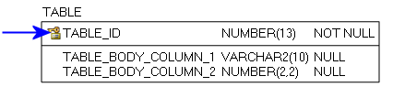

Figure 1: Primary Key example

**Foreign Key (FK):**

When a Primary Key from a Parent Table appears as a column in the Child Table it is referred to as a Foreign Key (FK). The FK may retain the same name of the Parent Table column, or it may be renamed.

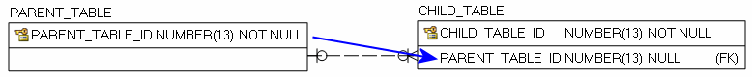

Figure 2: Foreign Key example

**Alternate Key (AK):**

Alternate Keys (AK) are secondary unique identifiers in a Parent Table. A Child Table can link to a Parent Table AK and use it as a Foreign Key (FK). The FK may retain the same name of the Parent Table column, or it may be renamed. Alternate Keys allow null values.



Figure 3: Alternate Key example

There are two relationship type options, identifying and non-identifying, which are described below.

An **Identifying Relationship** occurs when a column from the Parent Table is added to the key section of the Child Table. Though technically a Foreign Key (FK) in the child table, it now forms part of the Primary Key (PK). Identifying Relationships are symbolized with a solid line.

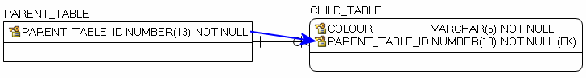

Figure 4: Example of an Identifying Relationship

A **Non-identifying Relationship** occurs when a column from the Parent Table is added to the main body of the Child Table where it is treated as a Foreign Key (FK). Non-identifying Relationships are symbolized with a dashed line.

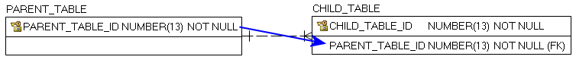

Figure 5: Example of a Non-identifying Relationship

The relationships between tables are set up with cardinality rules describing if the feature record in the Parent Table can relate to zero, one or more records in the associated Child Table and vice versa. These rules are symbolized in the model diagram as follows.

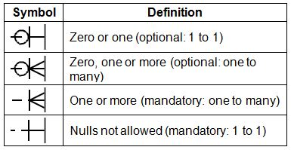

Figure 6: Model Diagram Relationship Symbology Table

The following section is an index of parent table primary keys identifying, where applicable, associated child table dependencies that have been implemented for the ORN Segment with Address data class.

Main Business Area Tables

Index of main business area table primary and associated foreign keys.

Note: Relationship type reference is either Identifying (I) or Non-Identifying (NI).

Parent Table: **ORN_ROAD_SEGMENT_WITH_ADDRESS_FT**

Primary Key(s): **OGF_ID**

Data Type: **NUMBER (13)**

| Child Table | Migrated Foreign Key | Rel. Type | Parent to Child Relationship | Child to Parent Relationship |
| --- | --- | --- | --- | --- |
| Not applicable (N/A) | N/A | N/A | N/A | N/A |

Lookup Table Indexes

Where a lookup table primary key (PK) is used as a foreign key (FK) in other main business area tables in order to control permissible values.

Note: Relationship type reference is either Identifying (I) or Non-Identifying (NI).

Parent Table: **ORN_DIR_OF_TRAFFIC_FLOW_LIST**

Primary Key(s): **DIRECTION_OF_TRAFFIC_FLOW**

Data Type: **VARCHAR2 (8)**

| Child Table | Migrated Foreign Key | Rel. Type | Parent to Child Relationship | Child to Parent Relationship |
| --- | --- | --- | --- | --- |
| ORN_SEGMENT_WITH_ADDRESS_FT | DIRECTION_OF_TRAFFIC_FLOW | NI | Optional: 1 to many | Mandatory: 1 to1 |

Parent Table: **ORN_HOUSE_NUM_STRUCTURE_LIST**

Primary Key(s): **HOUSE_NUMBER_STRUCTURE**

Data Type: **VARCHAR2 (10)**

| Child Table | Migrated Foreign Key | Rel. Type | Parent to Child Relationship | Child to Parent Relationship |
| --- | --- | --- | --- | --- |
| ORN_SEGMENT_WITH_ADDRESS_FT | L_HOUSE_NUMBER_STRUCTURE | NI | Optional: 1 to many | Optional: 1 to1 |
| ORN_SEGMENT_WITH_ADDRESS_FT | R_HOUSE_NUMBER_STRUCTURE | NI | Optional: 1 to many | Optional: 1 to1 |

Parent Table: **ORN_ROAD_CLASS_LIST**

Primary Key(s): **ROAD_CLASS**

Data Type: **VARCHAR2 (25)**

| Child Table | Migrated Foreign Key | Rel. Type | Parent to Child Relationship | Child to Parent Relationship |
| --- | --- | --- | --- | --- |
| ORN_SEGMENT_WITH_ADDRESS_FT | ROAD_CLASS | NI | Optional: 1 to many | Optional: 1 to1 |

Parent Table: **ORN_ROAD_ELEMENT_TYPE_LIST**

Primary Key(s): **ROAD_ELEMENT_TYPE**

Data Type: **VARCHAR2 (20)**

| Child Table | Migrated Foreign Key | Rel. Type | Parent to Child Relationship | Child to Parent Relationship |
| --- | --- | --- | --- | --- |
| ORN_SEGMENT_WITH_ADDRESS_FT | ROAD_ELEMENT_TYPE | NI | Optional: 1 to many | Optional: 1 to1 |

Parent Table: **ORN_SHIELD_TYPE_LIST**

Primary Key(s): **SHIELD_TYPE**

Data Type: **VARCHAR2 (60)**

| Child Table | Migrated Foreign Key | Rel. Type | Parent to Child Relationship | Child to Parent Relationship |
| --- | --- | --- | --- | --- |
| ORN_SEGMENT_WITH_ADDRESS_FT | SHIELD_TYPE | NI | Optional: 1 to many | Optional: 1 to1 |

Parent Table: **ORN_STANDARD_MUNICIPALITY_LIST**

Primary Key(s): **STANDARD_MUNICIPALITY**

Data Type: **VARCHAR2 (100)**

| Child Table | Migrated Foreign Key | Rel. Type | Parent to Child Relationship | Child to Parent Relationship |
| --- | --- | --- | --- | --- |
| ORN_SEGMENT_WITH_ADDRESS_FT | L_STANDARD_MUNICIPALITY | NI | Optional: 1 to many | Optional: 1 to1 |
| ORN_SEGMENT_WITH_ADDRESS_FT | R_STANDARD_MUNICIPALITY | NI | Optional: 1 to many | Optional: 1 to1 |

Parent Table: **ORN_STREET_DIRECTION_LIST**

Primary Key(s): **STREET_DIRECTION**

Data Type: **VARCHAR2 (10)**

| Child Table | Migrated Foreign Key | Rel. Type | Parent to Child Relationship | Child to Parent Relationship |
| --- | --- | --- | --- | --- |
| ORN_SEGMENT_WITH_ADDRESS_FT | DIRECTIONAL_PREFIX | NI | Optional: 1 to many | Optional: 1 to1 |
| ORN_SEGMENT_WITH_ADDRESS_FT | DIRECTIONAL_SUFFIX | NI | Optional: 1 to many | Optional: 1 to1 |

Parent Table: **ORN_STREET_TYPE_LIST**

Primary Key(s): **STREET_TYPE**

Data Type: **VARCHAR2 (25)**

| Child Table | Migrated Foreign Key | Rel. Type | Parent to Child Relationship | Child to Parent Relationship |
| --- | --- | --- | --- | --- |
| ORN_SEGMENT_WITH_ADDRESS_FT | STREET_TYPE_PREFIX | NI | Optional: 1 to many | Optional: 1 to1 |
| ORN_SEGMENT_WITH_ADDRESS_FT | STREET_TYPE_SUFFIX | NI | Optional: 1 to many | Optional: 1 to1 |

APPENDIX C: Frequently Asked Questions

What is the difference between ORN Road Net Element (ORNELEM) and ORN Segment with Address (ORNSEGAD)?

ORNELEM is a LRS data class that locates point and line events along a linear segment at distance measures. ORNSEGAD is a segmented data class derived from the ORN Road Net Element and includes fewer attributes.

Attribute tables included in ORNELEM:

* ORN_ROAD_NET_ELEMENT_FT
* ADDRESS_INFO
* ALTERNATE_STREET_NAME
* BLOCKED PASSAGE
* JUNCTION
* JURISDICTION
* NUMBER_OF_LANES
* OFFICIAL_STREET_NAME
* ROAD_CLASS
* ROAD_NET_ELEMENT_SOURCE
* ROUTE_NAME
* ROUTE_NUMBER
* SPEED_LIMIT
* STREET_NAME_PARSED
* STRUCTURE
* TOLL_POINT
* UNDERPASS

Attributes included in ORNSEGAD:

* ADDRESS_INFO (in separate fields)
* ALTERNATE_STREET_NAME
* DIRECTION_OF_TRAFFIC_FLOW (found in ORNELEM in ORN_ROAD_NET_ELEMENT_FT)
* OFFICIAL_STREET_NAME
* ROAD_CLASS
* ROAD_NET_ELEMENT_TYPE (found in ORNELEM in ORN_ROAD_NET_ELEMENT_FT)
* ROUTE_NAME
* ROUTE NUMBER
* STREET_NAME_PARSED (in separate fields)

For more information please visit the LIO metadata records for [ORN Road Net Element](https://www.javacoeapp.lrc.gov.on.ca/geonetwork/srv/en/main.home?uuid=290bfd40-0c8b-46d0-9a6c-0c648d096515) (https://www.javacoeapp.lrc.gov.on.ca/geonetwork/srv/en/main.home?uuid=290bfd40-0c8b-46d0-9a6c-0c648d096515) and [ORN Segment with Address](https://www.javacoeapp.lrc.gov.on.ca/geonetwork/srv/en/main.home?uuid=c7c7202d-942d-47dc-bb15-259eb71f2551) (https://www.javacoeapp.lrc.gov.on.ca/geonetwork/srv/en/main.home?uuid=c7c7202d-942d-47dc-bb15-259eb71f2551).

What is a Linear Reference System (LRS)?

A Linear Reference System (LRS) allows attributes to be assigned to specific positions (distance measures) along a linear segment. Attributes are stored in separate tables and linked to the geometry through a unique ID.

For additional information on Linear Referencing visit ESRI’s ArcGIS Resources: [What is linear referencing?](http://resources.arcgis.com/en/help/main/10.1/index.html#//003900000001000000) (http://resources.arcgis.com/en/help/main/10.1/index.html#//003900000001000000)

Where are the attribute tables for the ORN_ROAD_NET_ELEMENT data class?

If downloading data through the [LIO Metadata Management Tool](https://www.javacoeapp.lrc.gov.on.ca/geonetwork/srv/en/main.home?uuid=290bfd40-0c8b-46d0-9a6c-0c648d096515) (https://www.javacoeapp.lrc.gov.on.ca/geonetwork/srv/en/main.home?uuid=290bfd40-0c8b-46d0-9a6c-0c648d096515), the attribute tables are provided.

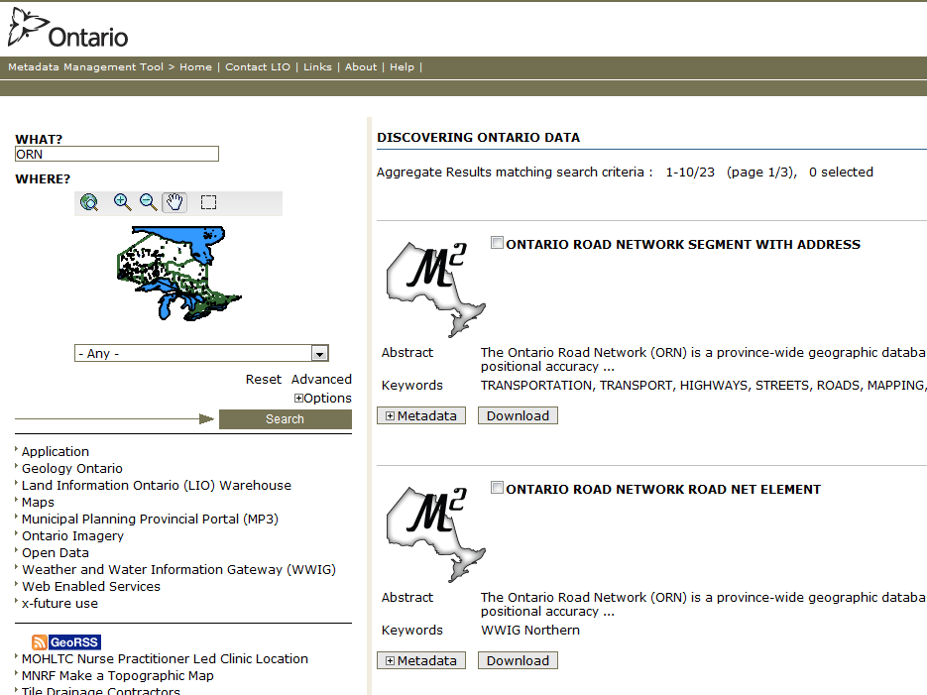

Figure 7: Attribute tables included through LIO Metadata Management Tool

Ontario Geospatial Data Exchange (OGDE) members must select ‘Include Related Tables’ when ordering data from LIO Data Warehouse. When you reach the **Select Data** tab make sure ‘Include Related Tables’ is checked.

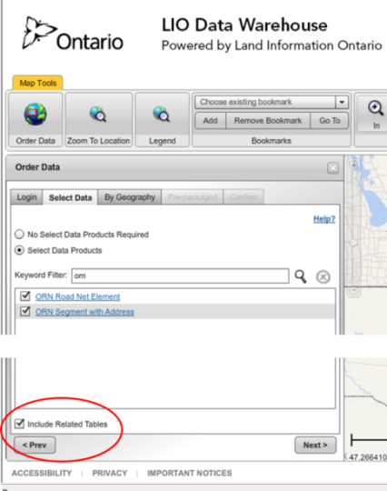

Figure 8: Check 'Include Related Tables' when ordering LIO data

Why can’t I see ORN attributes like Speed Limit or Road Class in ArcMap?

Some attributes, like Speed Limit, are only available in ORN Road Net Element (see What is the difference between ORN Road Net Element and ORN Segment with Address?). ORN attribute tables will not draw in ESRI’s ArcMap unless they are displayed as Route Events. Route Events are created from the event (attribute) tables using distance measures. In the ORN the measures are FROM_MEASURE and TO_MEASURE for line events and AT_MEASURE for point events. Measures and an identifier called ROAD_NET_ELEMENT_ID locate the events on the geometry. Once displayed the Route Event is like any other layer and can be symbolized and analyzed. In ORNELEM, most route events can be displayed using Display Route Events. To display ORN_JUNCTION use Display XY Data (explained below).

For more information on which attributes are available in each data class, visit the LIO metadata records for [ORN Road Net Element](https://www.javacoeapp.lrc.gov.on.ca/geonetwork/srv/en/main.home?uuid=290bfd40-0c8b-46d0-9a6c-0c648d096515) (https://www.javacoeapp.lrc.gov.on.ca/geonetwork/srv/en/main.home?uuid=290bfd40-0c8b-46d0-9a6c-0c648d096515) and [ORN Segment with Address](https://www.javacoeapp.lrc.gov.on.ca/geonetwork/srv/en/main.home?uuid=c7c7202d-942d-47dc-bb15-259eb71f2551) (https://www.javacoeapp.lrc.gov.on.ca/geonetwork/srv/en/main.home?uuid=c7c7202d-942d-47dc-bb15-259eb71f2551).

For additional information on Route Events visit ESRI’s ArcGIS Resources: [An overview of displaying and querying route events](http://desktop.arcgis.com/en/desktop/latest/guide-books/linear-referencing/an-overview-of-displaying-and-querying-route-event.htm) (http://desktop.arcgis.com/en/desktop/latest/guide-books/linear-referencing/an-overview-of-displaying-and-querying-route-event.htm).

How do I display ORN Route Events in ArcMap?

To display ORN route events in ArcMap (version 10.1):

1. Add the ORN_ROAD_NET_ELEMENT feature class to the Table of Contents (TOC)
2. Add an event table, e.g. ROAD_CLASS
3. In the TOC ‘List by Source’ tab, right-click on the ROAD_CLASS event table and select ‘Display Route Events’. A dialog box opens.
   1. Route Reference: ORN_ROAD_NET_ELEMENT
   2. Route Identifier: OGF_ID (or FMF_OBJECT_ID, depending on data vintage)
   3. Event Table: ROAD_CLASS
   4. Route Identifier: ROAD_NET_ELEMENT_ID
   5. Choose Point or Line Events. E.g. ROAD_CLASS is Line; for points select AT_MEASURE
      1. From-Measure: FROM_MEASURE
      2. To-Measure: TO_MEASURE Offset: <None>
4. Click OK. A new layer appears which can be symbolized, queried, and updated as if it was any other feature class.

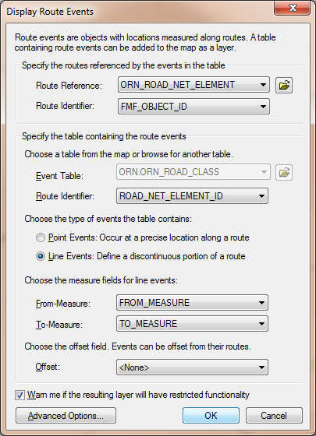

Figure 9: ArcMap's Display Route Events

How do I display the ORN_JUNCTION table in ArcMap?

The ORN_JUNCTION table uses x and y coordinates instead of distance measures for positions.

To display Junctions in ArcMap (version 10.1):

1. Add the ORN_ROAD_NET_ELEMENT feature class to the Table of Contents (TOC)
2. Add the JUNCTION event table
3. In the TOC ‘List by Source’ tab, right-click on the JUNCTION event table and select ‘Display XY Data’. A dialog box opens.
   1. X Field: LONGITUDE_DECIMAL_DEGREES
   2. Y Field: LATITUDE_DECIMAL_DEGREES
   3. Z Field: <None>
   4. Coordinate System Description: Geographic Coordinate System: Name: GCS_North_American_1983
4. Click OK. Junction points will appear at ends of linear segments, suitable for symbolizing and analysis.

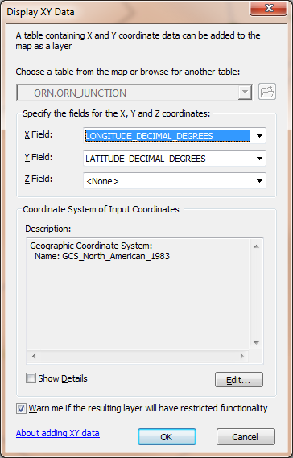

Figure 10: ArcMap's Display XY Data

How do I join ORN tables or event layers?

To create a simple join using ORNELEM event tables or route events in ArcMap (version 10.1):

1. In the Table of Contents (TOC), select the event or feature class to join, e.g. ORN_ROAD_NET_ELEMENT.
2. In the TOC right-click on the ORN_ROAD_NET_ELEMENT and select Joins and Relates, then Join…
3. In the Join Data dialog box:
   1. First Join field is the OGF_ID (OBJECT_ID (or FMF_OBJECT_ID, depending on data vintage)
   2. Choose the table to join to ORN_ROAD_NET_ELEMENT, e.g. ORN_ADDRESS_INFO
   3. Second Join field is ROAD_NET_ELEMENT_ID
   4. Choose either ‘Keep all records’ or ‘Keep only matching records’, depending on need.
4. Click OK. This step can be run multiple times to attach tables and route events.

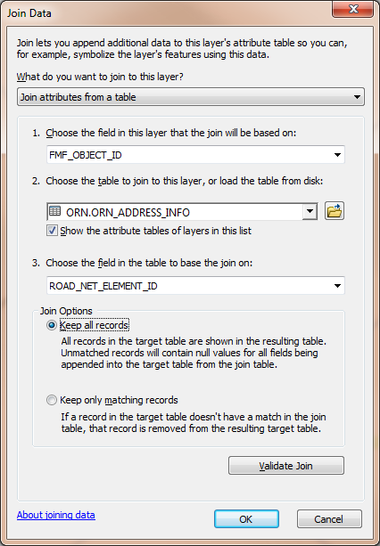

Figure 11: ArcMap's Join Data

How do I access ORN attributes for analysis?

In order to query more of the data, you can join tables or route events to each other or the ORN geometry. As an example, a query could be designed to identify Bridges (ORN_STRUCTURE) on Freeways (ORN_ROAD_CLASS).

For additional information on joining tables in ArcMap, visit ESRI’s ArcGIS Resources: [Joining attributes in one table to another](http://desktop.arcgis.com/en/desktop/latest/manage-data/tables/joining-attributes-in-one-table-to-another.htm) (http://desktop.arcgis.com/en/desktop/latest/manage-data/tables/joining-attributes-in-one-table-to-another.htm).

Where do I find 911 addresses?

The ORN receives data from authoritative sources responsible for 911 address management for the purposes of emergency management. Not all areas of Ontario are covered by a 911 addressing management system but those areas will typically have a system of addressing assigned to roads which are represented in the ORN. Addressing information is available in ORN Road Net Element in the ADDRESS_INFO table, and in the ORN Segment with Address attributes.

What is the difference between 911 and civic addresses?

A civic address consists of a street number, street name, municipality name, province code and postal code. A 911 address is similar and they combine to uniquely describe a specific location to help emergency services locate properties. In some areas of the province, a 911 address and civic address terms are used interchangeably or a 911 address may only refer to rural properties.

What is the difference between shield type and road class?

A shield type identifies a route assigned by a road authority, e.g. MTO, and is also used for cartographic purposes. Shield Type is part of ROUTE_NUMBER, found in both ORNELEM and ORNSEGAD. A road class identifies a type of road based on a functional class (e.g. highway, arterial). The ROAD_CLASS table is in both ORN data classes.

What is the difference between the Jurisdiction, Agency Name, and Road Net Element Source tables?

Jurisdiction indicates the agency has custodianship of a road with responsibility to ensure maintenance occurs but may not undertake it directly. Jurisdiction is not available in ORNSEGAD.

An Agency Name identifies the source agency that provided attributes. Agency Name is not available in ORNSEGAD.

The Road Net Element Source identifies the source agency that provided road net element geometry. Often Road Net Element Source and Agency Name are the same. Road Net Element Source is not available in ORNSEGAD.

What projection is used to calculate LENGTH in ORN?

The length of the ORN Road Net Element is calculated in UTM. Each feature determines which UTM projection to use based on the centre of the feature.

UTM Zones in Ontario:

* 15 = -96 to -90
* 16 = -90 to -84
* 17 = -84 to -78
* 18 = -78 to -72

I found a road with an offensive or rescinded name in the ORN. Are you able to rename the road or remove the name?

The ORN relies on partner organizations to provide road data. As we are not the official source of the data we cannot rename or remove the name of a road feature. The quality control processes used to maintain the ORN will identify names that have been rescinded by the Government of Ontario. If a name is identified the ORN team will inform the original source of the data. It is at the discretion of the source data owner to decide if a name is to be rescinded. Users can contact source data owners directly to inquire about road names.

I still need help!

For more information visit [LIO](http://www.ontario.ca/environment-and-energy/land-information-ontario) (http://www.ontario.ca/environment-and-energy/land-information-ontario) or email your questions to [lio@ontario.ca](mailto:lio@ontario.ca).

APPENDIX D: Creating a Network with ORN Segment with Address (ORNSEGAD)

1. Introduction

The ORNSEGAD data class can be used to create a network for analysis and routing. The following appendix demonstrates one method for creating a network dataset using ArcGIS and the Network Analyst extension. However, there are many different ways to build a network using various software packages.

2. Creating the Network

2.1. Steps for Preparing the ORNSEGAD

Network datasets often include travel time as a cost attribute to be used in their networking algorithms. However, ORNSEGAD does not contain the speed limit attribute information necessary for calculating travel time. One potential solution is to estimate speed limits based on road class. Possible example values are showing in Table 1.

Table 1 – Possible speed limits for ORN road classes

|  |  |
| --- | --- |
| ORN Road Class | Speed Limit |
| Freeway | 100 |
| Highway / Expressway | 80 |
| Arterial | 60 |
| Collector | 50 |
| Local / Street | 50 |
| Local / Strata | 50 |
| Resource / Rec | 50 |
| Service | 50 |
| Alleyway / Laneway | 40 |

* Add a new “Short Integer” field called “Speed” to the “ORN_SEGMENT_WITH_ADDRESS” shapefile (Figure 12).
* Open the “Select By Attributes…” window and select features within the “ORN_SEGMENT_WITH_ADDRESS” shapefile based on the “ROAD_CLASS” field (Figure 13).
* Open the “Field Calculator” on the “Speed” field to calculate the desired speed limit (Figure 14).

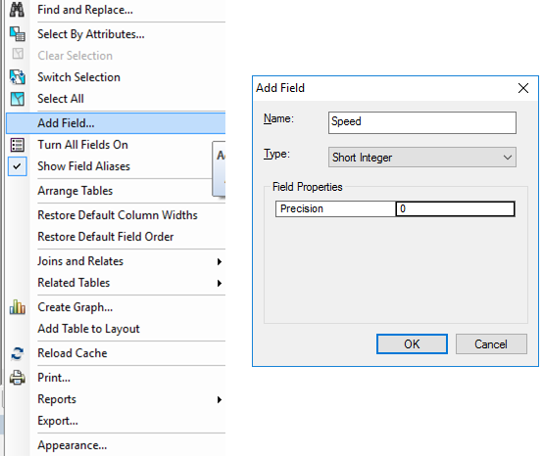

Figure 12 – Add a new field for speed values

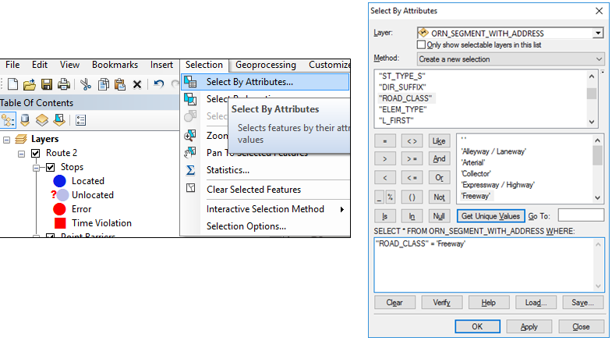

Figure 13 – Select features by road class

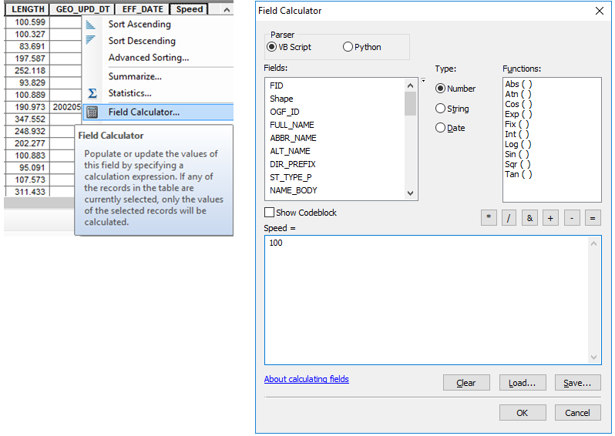

Figure 14 – Calculate the desired speed

2.2. Steps to Create the Network Dataset

* Open the “Extensions…” window and enable the “Network Analyst” extension (Figure 15).
* Right click the “ORN_SEGMENT_WITH_ADDRESS” shapefile and select “New Network Dataset…” (Figure 16).
* Enter a name for the new network dataset (Figure 17).
* Select the “Yes” radio button to model turns in the network (Figure 18).
* The default connectivity settings establish connectivity at coincident endpoints only. This is the ideal setting when working with the ORN. Note that junctions will not be created where roads overlap but do not intersect (ex. overpasses). Click next (Figure 19).
* The ORN does not contain elevation data. Select the “None” radio button and click next (Figure 20).

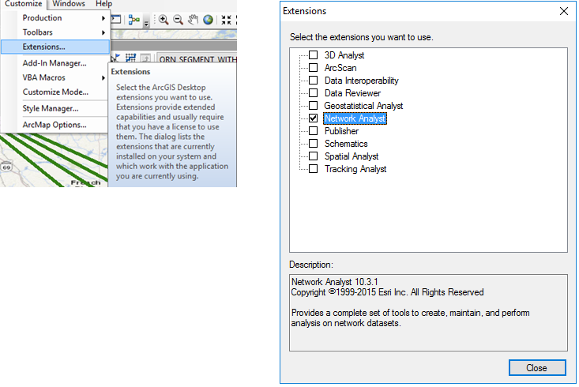

Figure 15 – Enable the “Network Analyst” extension

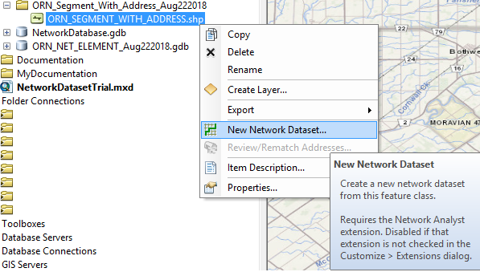

Figure 16 – Create a new network dataset

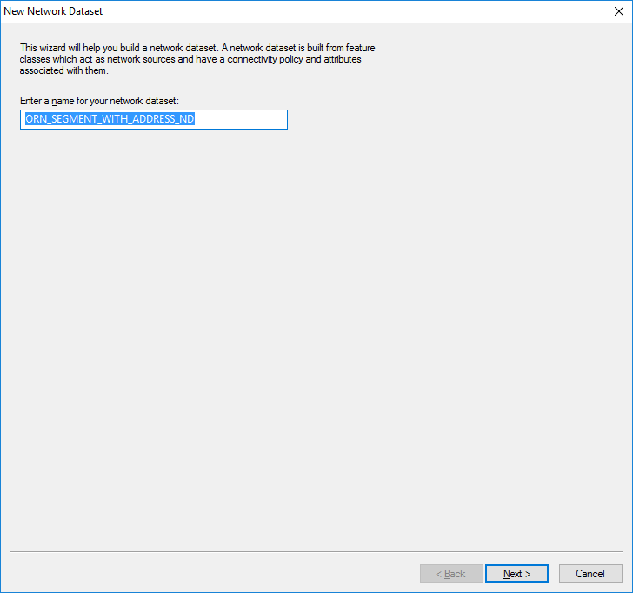

Figure 17 – Enter a name for the new network dataset.

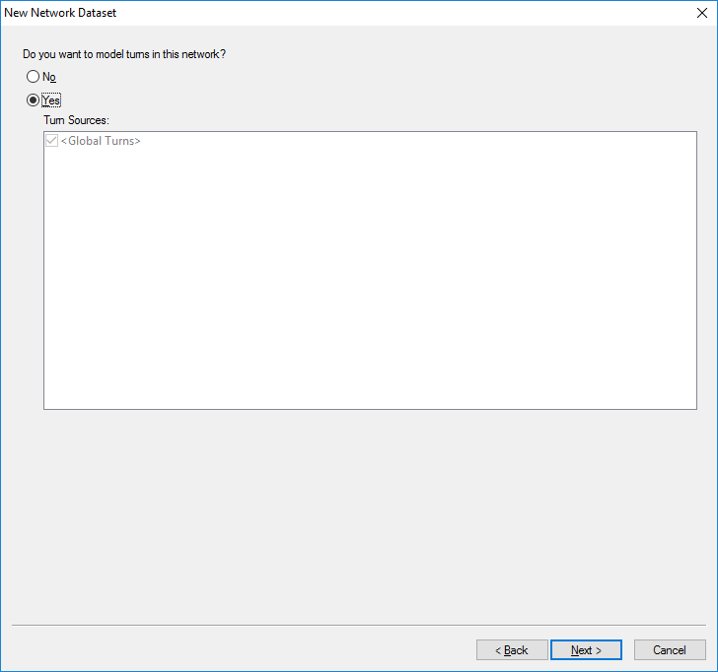

Figure 18 – Select the “Yes” radio button to model turns in the network.

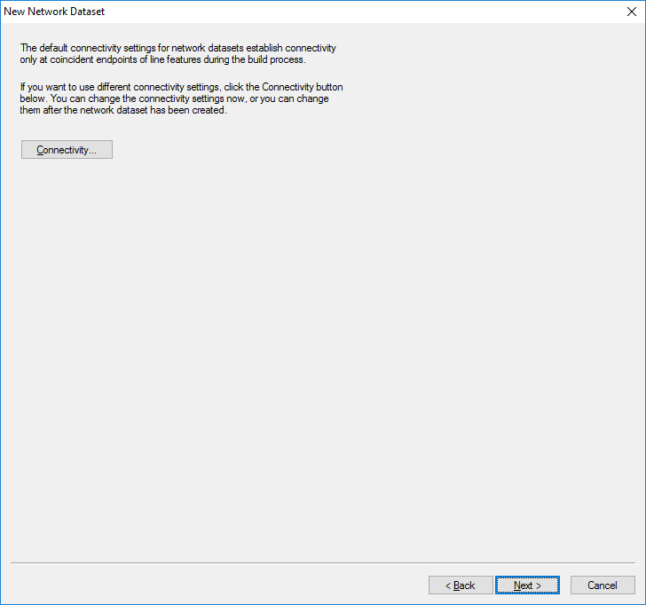

Figure 19 – Accept the default connectivity settings

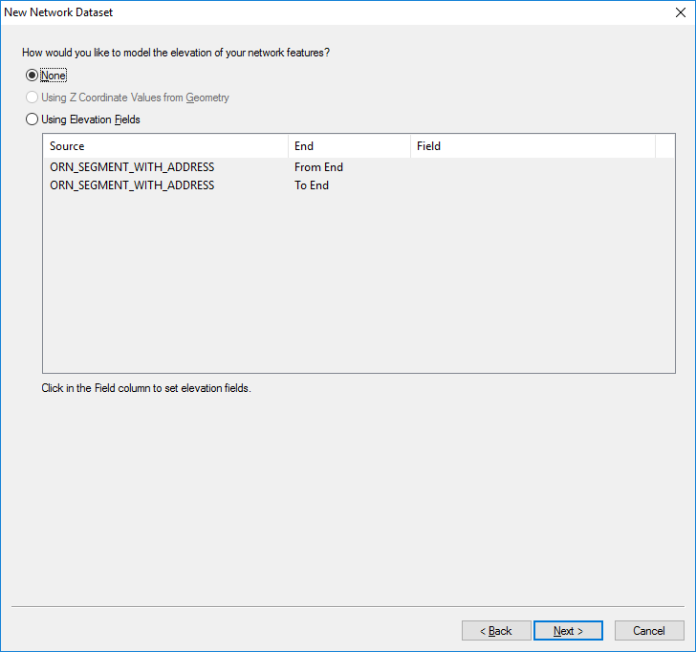

Figure 20 – Do not select an elevation model for the network.

2.3. Steps to Define the Network Attributes

* Add new attributes to the network dataset as shown in Table 2 and Figure 21.

Table 2 – Add these attributes to the Network Dataset

|  |  |  |  |
| --- | --- | --- | --- |
| Name | Usage | Units | Data Type |
| Length | Cost | Meters | Double |
| OneWay | Restriction | Unknown | Boolean |
| Rd_Class | Hierarchy | Unknown | Integer |
| Speed | Descriptor | KPH | Integer |
| Time | Cost | Minutes | Double |

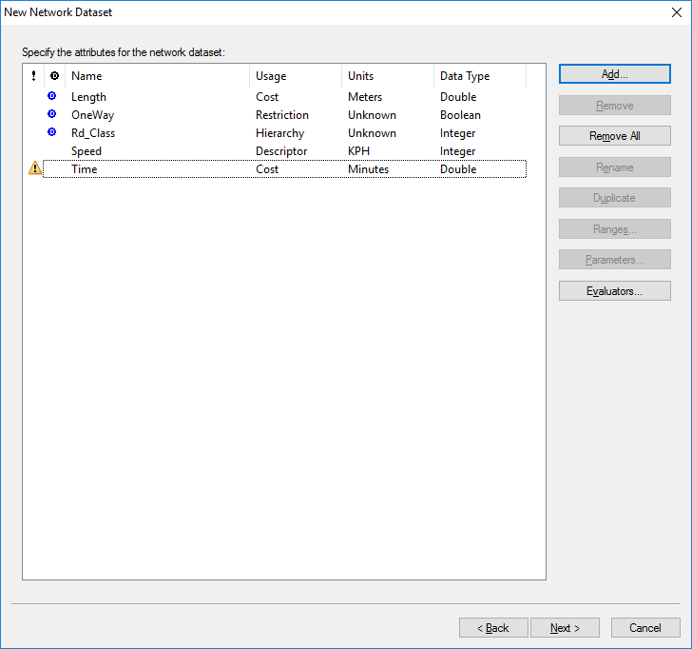

Figure 21 – Add the network attributes

2.3.1. Steps to Enforce One Way Restrictions

It is important to enforce traffic flow restrictions to ensure that rules along one way roads are followed and that network analyses behave as expected. The ORN_SEGMENT_WITH_ADDRESS dataset contains traffic flow direction information in the “DIRECTION” field. Possible values are described in Table 3.

Table 3 – Possible values in the “DIRECTION” field

|  |  |
| --- | --- |
| DIRECTION | Description |
| Both | Traffic can travel in both directions along the given segment |
| Positive | Traffic can only travel in the same direction as the segment’s geometry. |
| Negative | Traffic can only travel in the opposite direction as the segment’s geometry. |

* Highlight the “OneWay” attribute and select the “Evaluators…” button on the right (Figure 22).
* Set the “Type” column to “Field” for both edge elements. Highlight each edge element and click the “Evaluator Properties” button on the right (Figure 23).
* Set the value equal to the appropriate expression listed in Table 4 and click OK (Figure 24).

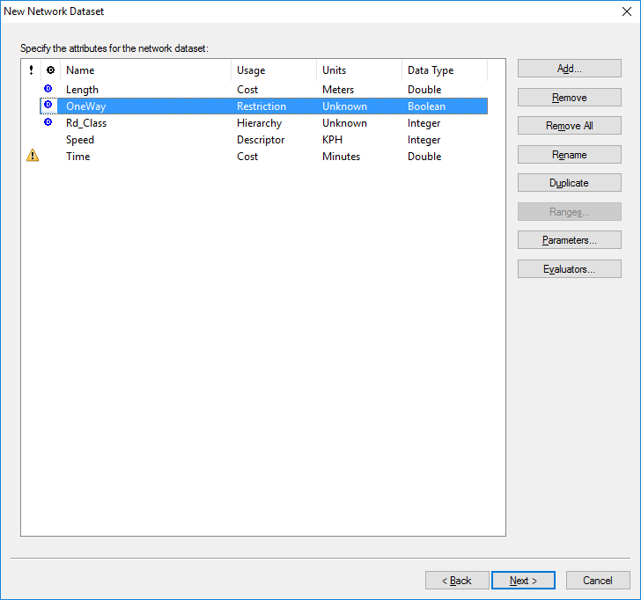

Figure 22 – Select the OneWay attribute

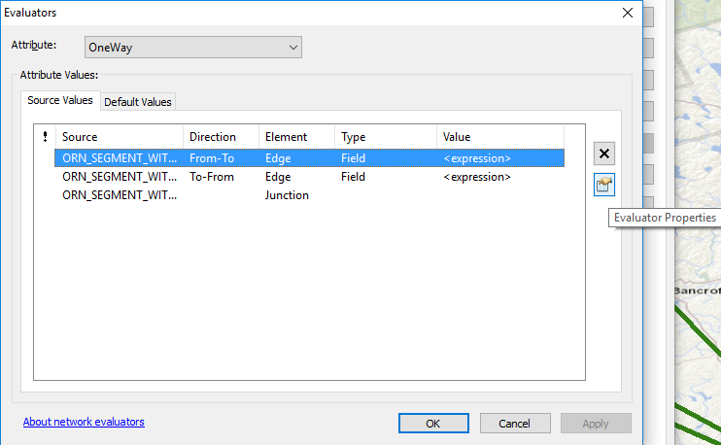

Figure 23 – Set OneWay evaluators

Table 4 – Expressions for enforcing traffic flow directions

|  |  |
| --- | --- |
| Direction | Value Expression |
| From-To | NOT ([DIRECTION] = "Both" OR [DIRECTION] = "Positive") |
| To-From | NOT ([DIRECTION] = "Both" OR [DIRECTION] = "Negative") |

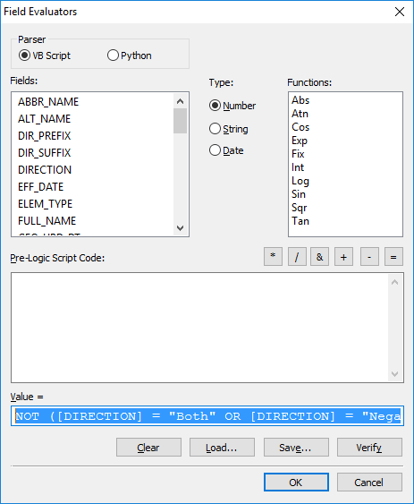

Figure 24 – Calculate the OneWay expression value

2.3.2. Steps to Build a Road Class Hierarchy

A hierarchy can be built using road classifications to help reduce network analysis computation time. The hierarchy classifies the roads into a number of levels which are then used by the networking algorithms to primarily search the higher levels of the hierarchy (ex. Travel over highways will be preferred over local roads). It is important to consider that enforcing a road hierarchy will often result in solutions with a higher cost (ex. total distances and travel times may be greater when using a hierarchy). It will be necessary to experiment with hierarchy settings if one decides to use it.

* On the Attributes window, highlight “Rd_Class” and click the “Evaluators…” button on the right (Figure 25).
* Set the “Type” column to “Field” for both edge elements. Highlight each edge element and click the “Evaluator Properties” button on the right (Figure 26).
* Write an expression to calculate an integer value for each road classification (Figure 27). An example Python script is shown below.

*Rd_Class = 4*

*if 'Freeway' in !ROAD_CLASS!:*

*Rd_Class = 1*

*elif 'Ramp' in !ROAD_CLASS!:*

*Rd_Class = 1*

*elif 'Highway' in !ROAD_CLASS!:*

*Rd_Class = 2*

*elif 'Arterial' in !ROAD_CLASS!:*

*Rd_Class = 2*

*elif 'Collector' in !ROAD_CLASS!:*

*Rd_Class = 3*

*elif 'Street' in !ROAD_CLASS!:*

*Rd_Class = 3*

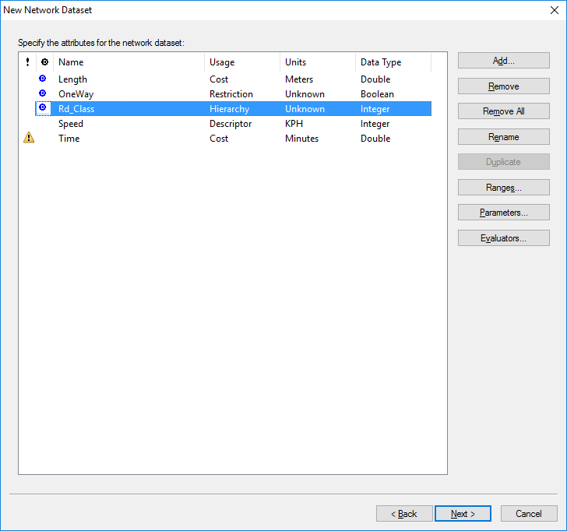

Figure 25 – Select the Rd_Class attribute

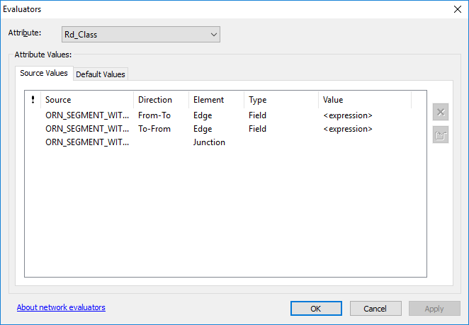

Figure 26 – Set the Rd_Class evaluators

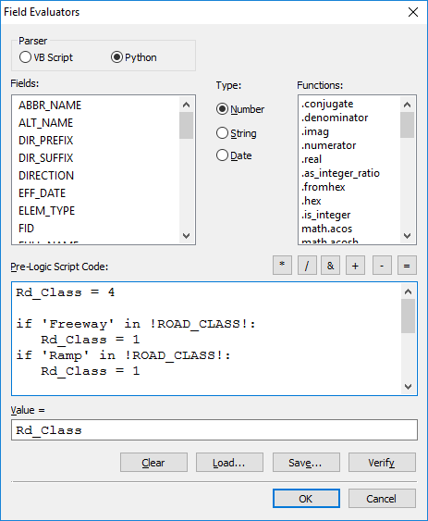

Figure 27 – Calculate the road class value

2.3.3. Steps to Estimate Travel Time

* On the “Attributes” window, highlight the “Speed” attribute and click the “Evaluators…” button (Figure 28).
* Set the Type column to “Field” and the Value column to “Speed” (Figure 29).
* On the “Attributes” window, highlight the “Time” attribute and click “Evaluators…” (Figure 30).
* Set the “Type” column to “Field” for both edge elements. Highlight each edge element and click the “Evaluator Properties” button on the right (Figure 31).
* Write an expression to calculate the time needed to travel each edge segment based on its length and speed limit (Figure 32). An example Python script is shown below.

time = ((!LENGTH! / 1000) / !Speed!) * 60

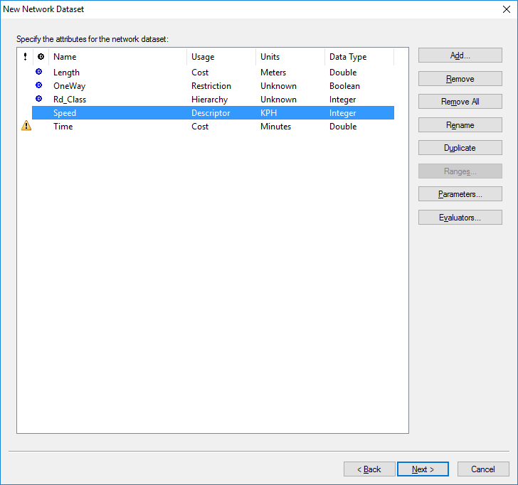

Figure 28 – Select the speed attribute

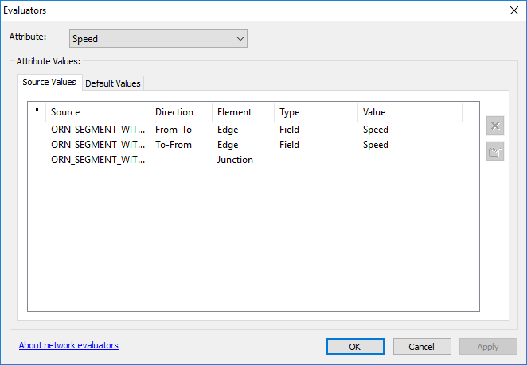

Figure 29 – Set the speed evaluators

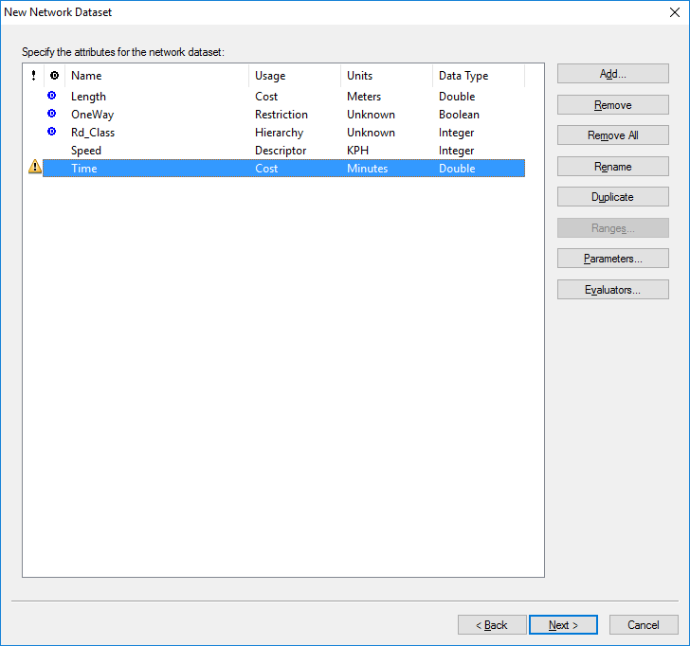

Figure 30 – Select the time attribute

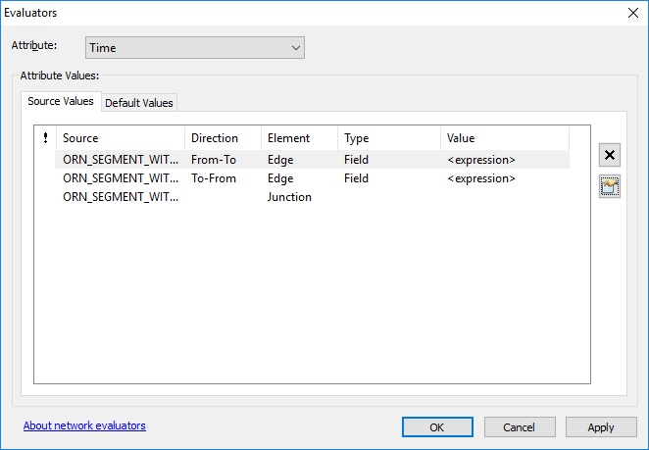

Figure 31 – Set the time evaluators

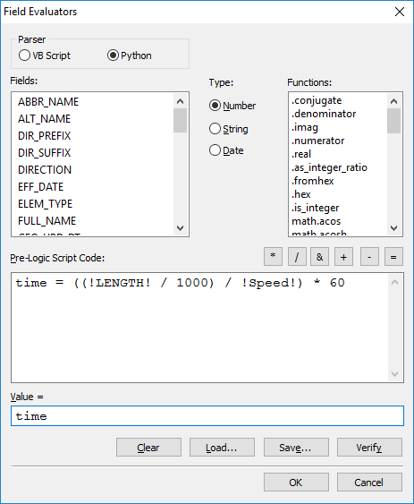

Figure 32 – Calculate the time evaluators

2.4. Steps to Establish Driving Directions

* Create a travel mode if desired. Otherwise, click “Next” (Figure 33).
* Select the “Yes” radio button to establish driving directions and click the “Directions…” button (Figure 34).
* Select the “General” tab and populate the street name columns with the field names as shown in Table 5 and Figure 35.
* Select the “Shields” tab and the “Pair of Fields” radio button. Set the type field to “SHEILD_T” and the number field to RTE_NUM_1. Click OK (Figure 36).

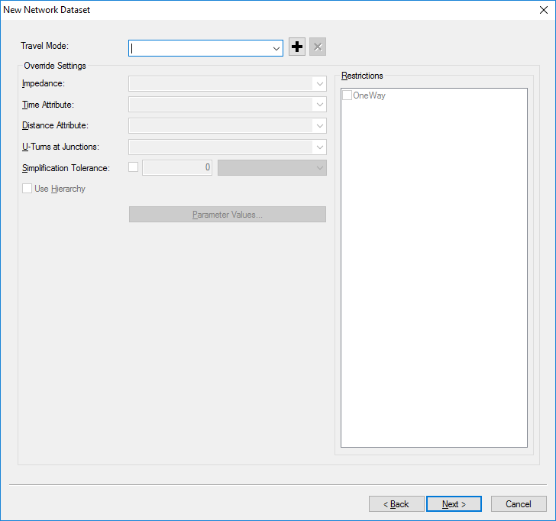

Figure 33 – The travel mode window

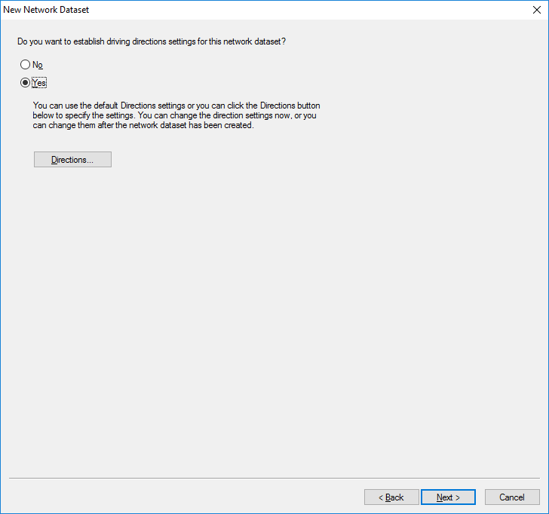

Figure 34 – The driving directions window

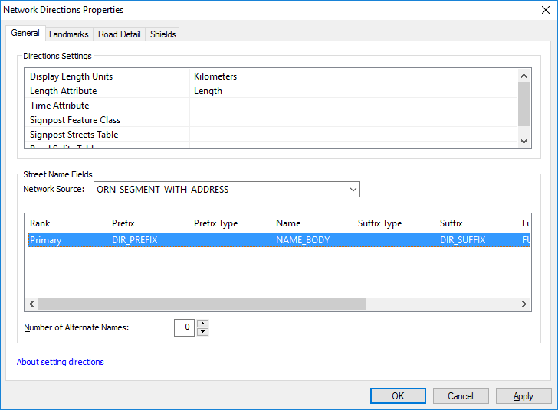

Figure 35 – Set the network direction properties

Table 5 – Network direction field values

|  |  |  |  |
| --- | --- | --- | --- |
| Prefix | Name | Suffix | Full Name |
| DIR_PREFIX | NAME_BODY | DIR_DUFFIX | FULL_NAME |

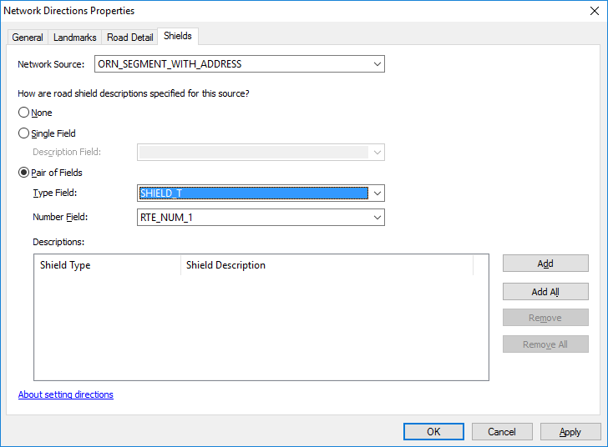

Figure 36 – Set the shield values

2.5. Steps to Finish Building the Network Dataset

* Review the Network Dataset summary and click the “Finish” button (Figure 37).
* Click the “Yes” button to build the dataset. Note that it may take a long time to build the dataset (Figure 38).
* View the completed network dataset (Figure 39).
* Begin exploring the different Network Analyst tools (Figure 40).

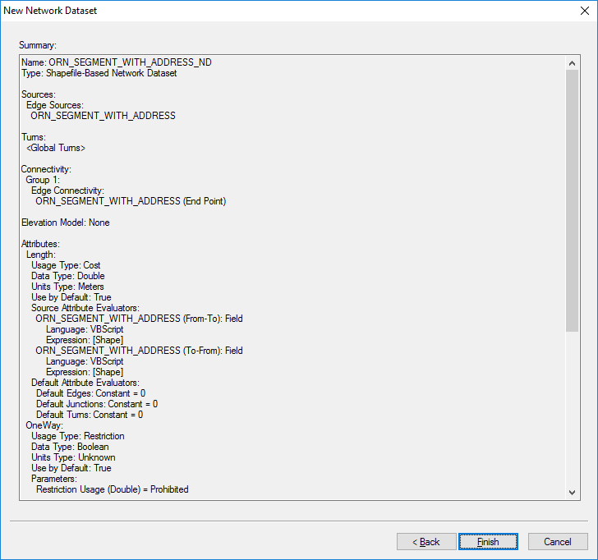

Figure 37 – The network dataset summary

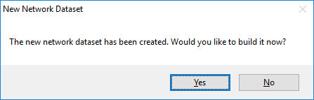

Figure 38 – Build the network dataset

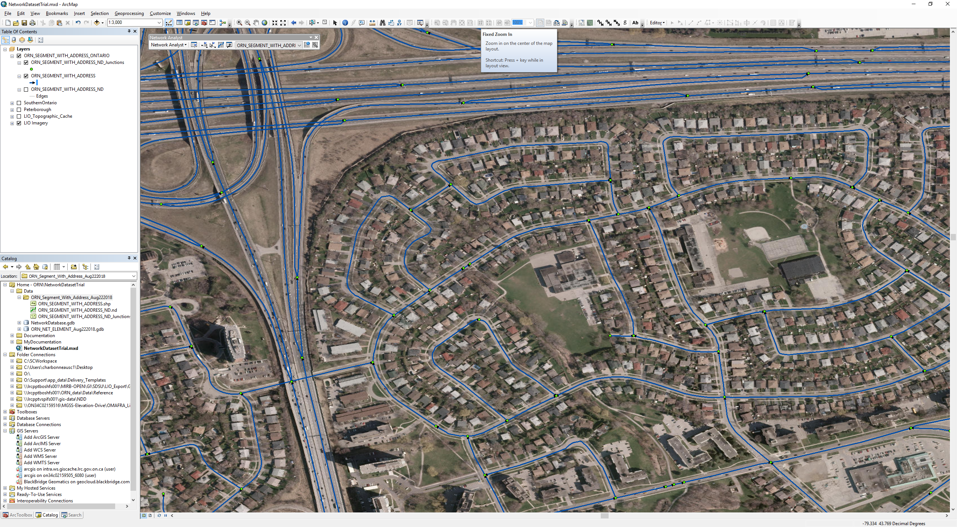

Figure 39 –The network dataset

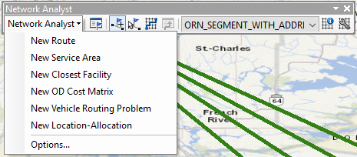

Figure 40 – The Network Analyst tools.

Version 1617.1